Mixed-Shape Composite Solids

Definition
# Source: AI Source: Provided by: [Data Path: Persons Table -> ID Column: 1, Name_En Column: Motasem Essam] -> From: [ChatGPT] on [7/25/2026]
Mixed-Shape Composite Solids are three-dimensional geometric objects formed by joining two or more different types of geometric solids, where the combined components may include both flat-faced solids and curved-surface solids.
Unlike prism-based, cylinder-based, cone-based, or sphere-based composite solids, mixed-shape composite solids do not depend on one particular solid as their main component. Instead, they combine different geometric solid categories to create a more complex three-dimensional structure.
Examples include:
- A rectangular prism joined to a cylinder and a cone.
- A cylinder combined with a sphere and a pyramid.
- A cone joined to a hemisphere and a rectangular prism.
- A prism combined with multiple cylinders, cones, and spheres.

Simple Definition
# Source: AI Source: Provided by: [Data Path: Persons Table -> ID Column: 1, Name_En Column: Motasem Essam] -> From: [ChatGPT] on [7/25/2026]
A mixed-shape composite solid is a 3D shape made by combining two or more different types of geometric solids.
For example, combining a rectangular prism, a cylinder, and a hemisphere creates a mixed-shape composite solid with flat faces and multiple types of curved surfaces.

Geometric Representation
# Source: AI Source: Provided by: [Data Path: Persons Table -> ID Column: 1, Name_En Column: Motasem Essam] -> From: [ChatGPT] on [7/25/2026]
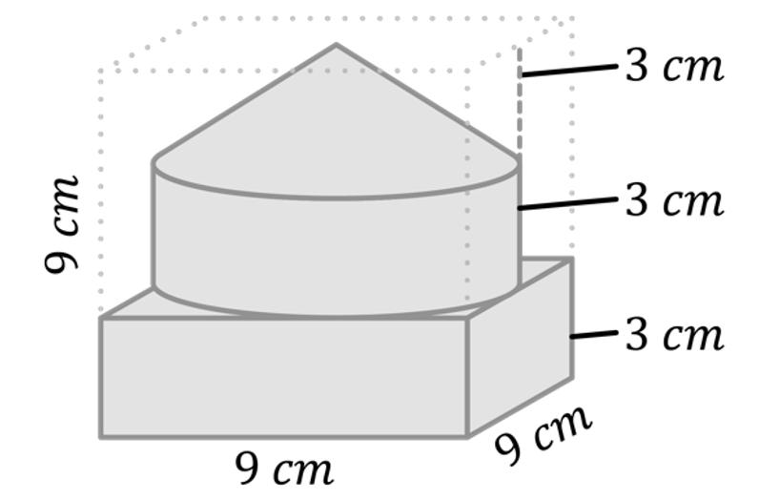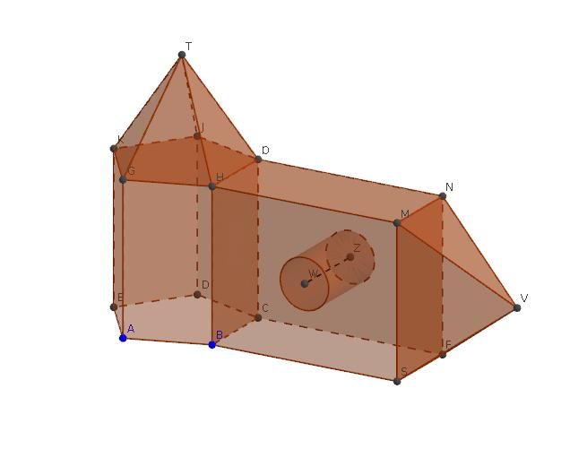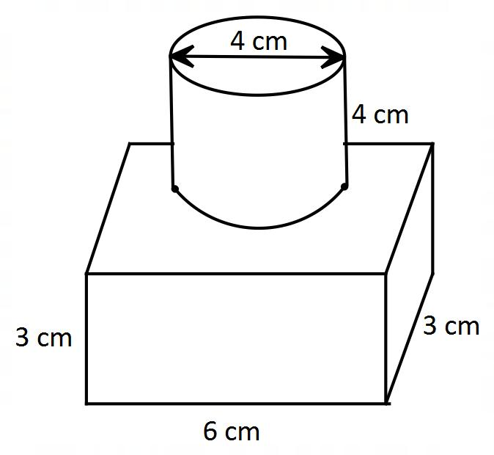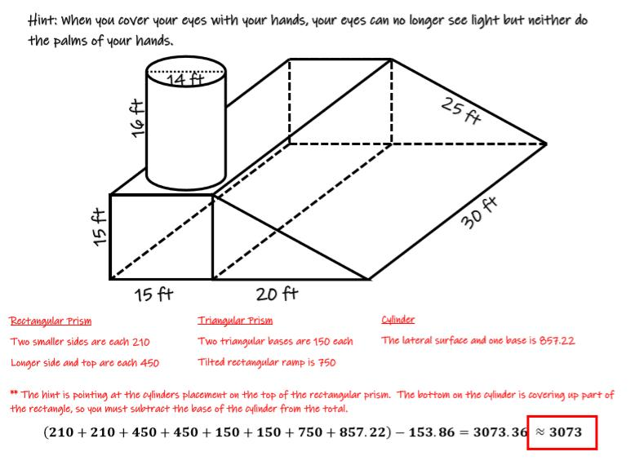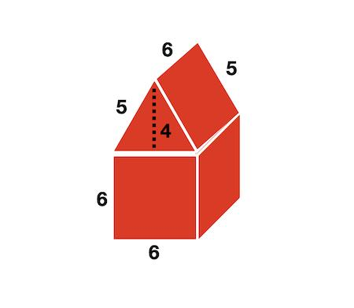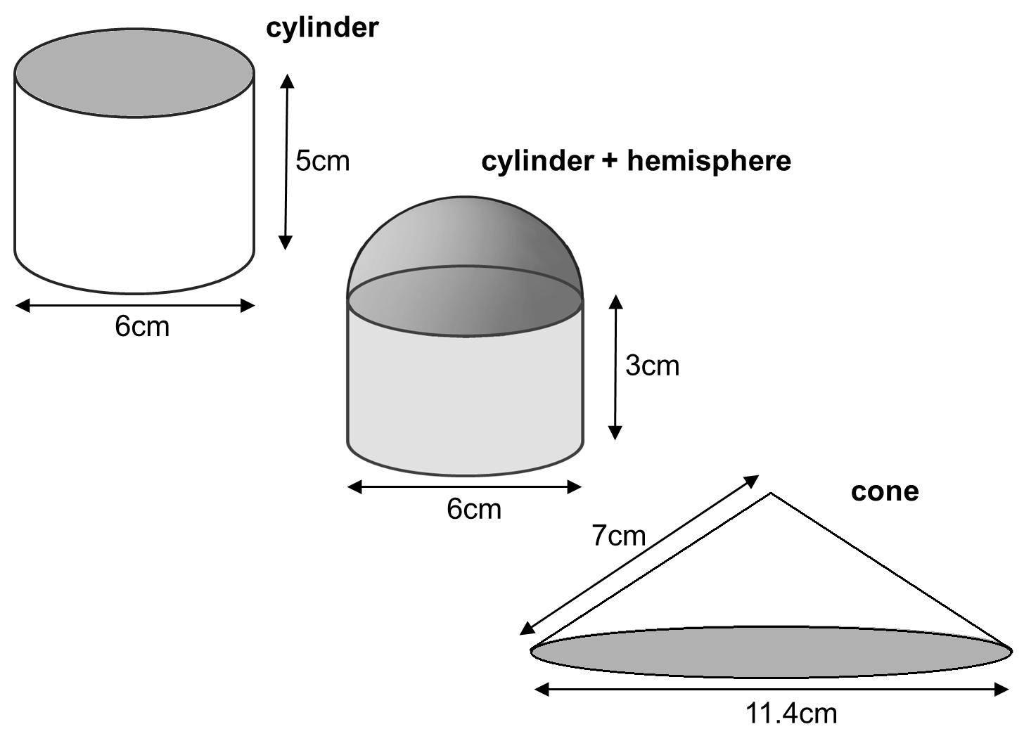
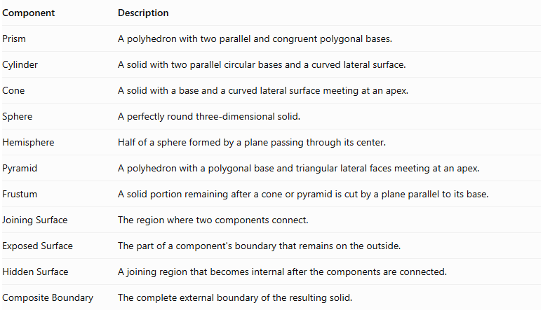
Component | Description
Prism | A polyhedron with two parallel and congruent polygonal bases.
Cylinder | A solid with two parallel circular bases and a curved lateral surface.
Cone | A solid with a base and a curved lateral surface meeting at an apex.
Sphere | A perfectly round three-dimensional solid.
Hemisphere | Half of a sphere formed by a plane passing through its center.
Pyramid | A polyhedron with a polygonal base and triangular lateral faces meeting at an apex.
Frustum | A solid portion remaining after a cone or pyramid is cut by a plane parallel to its base.
Joining Surface | The region where two components connect.
Exposed Surface | The part of a component's boundary that remains on the outside.
Hidden Surface | A joining region that becomes internal after the components are connected.
Composite Boundary | The complete external boundary of the resulting solid.

Types of Mixed-Shape Composite Solids

Prism-Cylinder Composite Solids
# Source: AI Source: Provided by: [Data Path: Persons Table -> ID Column: 1, Name_En Column: Motasem Essam] -> From: [ChatGPT] on [7/25/2026]
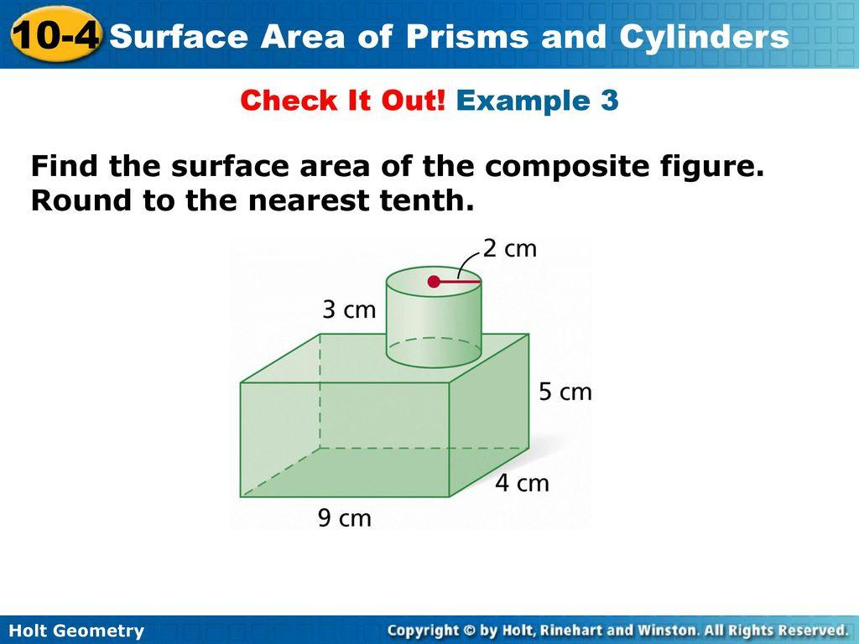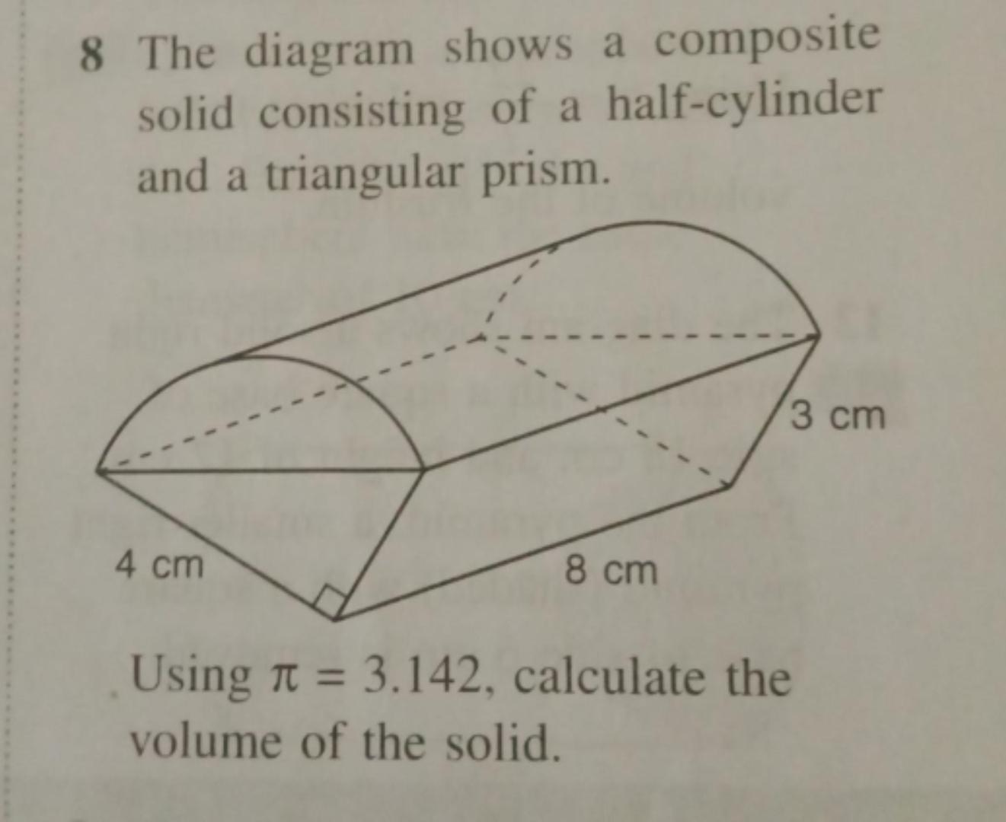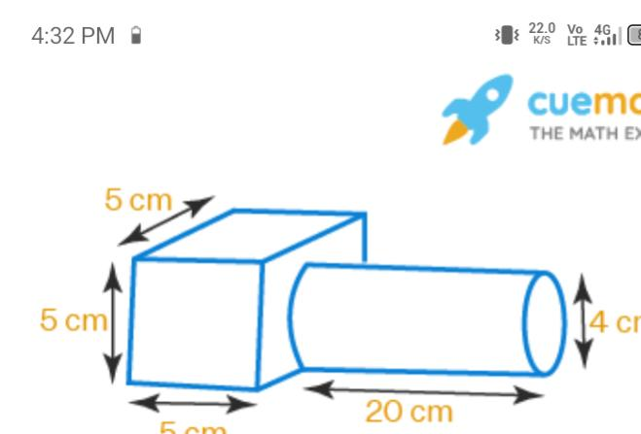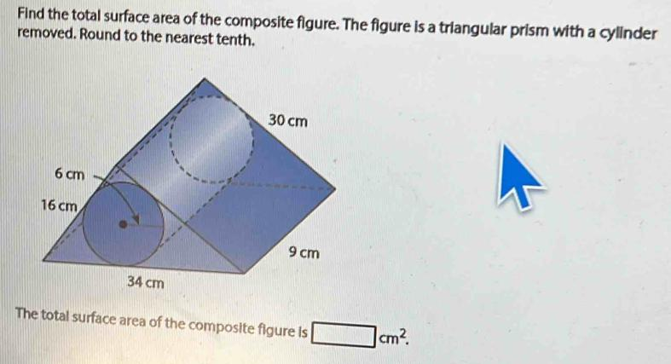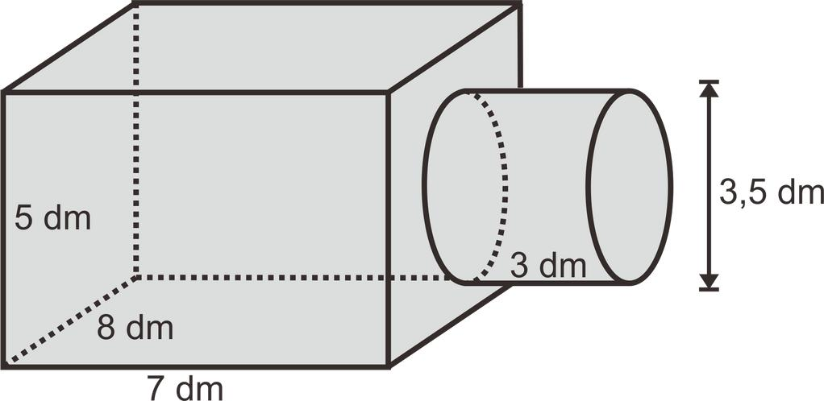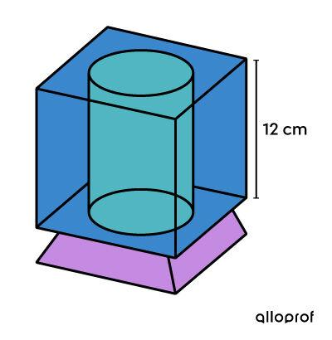
Formed by joining a prism with one or more cylinders.
Examples:
- Rectangular prism with a cylinder.
- Triangular prism with a cylinder.
- Square prism with multiple cylinders.
- Polygonal prism with a cylinder and another curved solid.

Prism-Cone Composite Solids
# Source: AI Source: Provided by: [Data Path: Persons Table -> ID Column: 1, Name_En Column: Motasem Essam] -> From: [ChatGPT] on [7/25/2026]
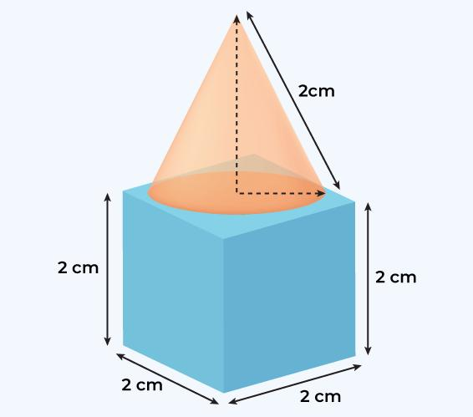
Formed by combining a prism with one or more cones.
Examples:
- Rectangular prism with a cone.
- Triangular prism with a cone.
- Square prism with multiple cones.
- Prism with cones attached to different faces.

Prism-Sphere Composite Solids
# Source: AI Source: Provided by: [Data Path: Persons Table -> ID Column: 1, Name_En Column: Motasem Essam] -> From: [ChatGPT] on [7/25/2026]
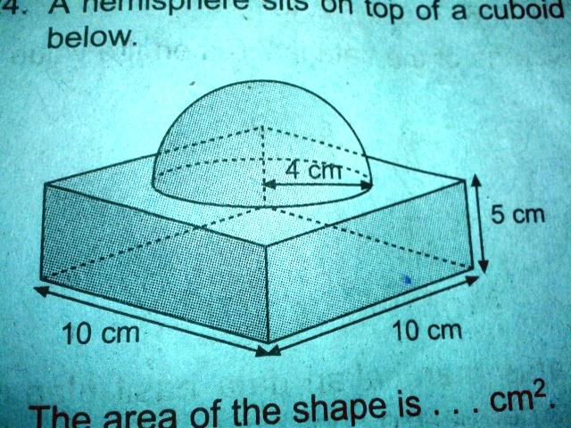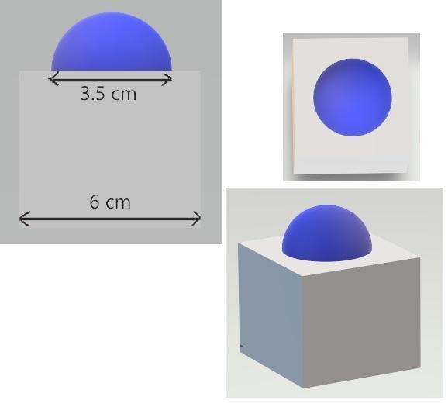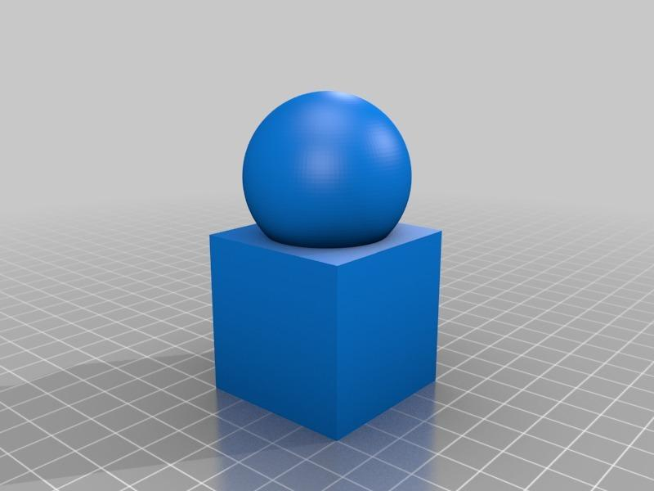
Formed by combining a prism with one or more spheres.
Examples:
- Rectangular prism with a sphere.
- Triangular prism with a sphere.
- Square prism with multiple spheres.
- Prism combined with spheres and hemispheres.

Prism-Pyramid Composite Solids
# Source: AI Source: Provided by: [Data Path: Persons Table -> ID Column: 1, Name_En Column: Motasem Essam] -> From: [ChatGPT] on [7/25/2026]
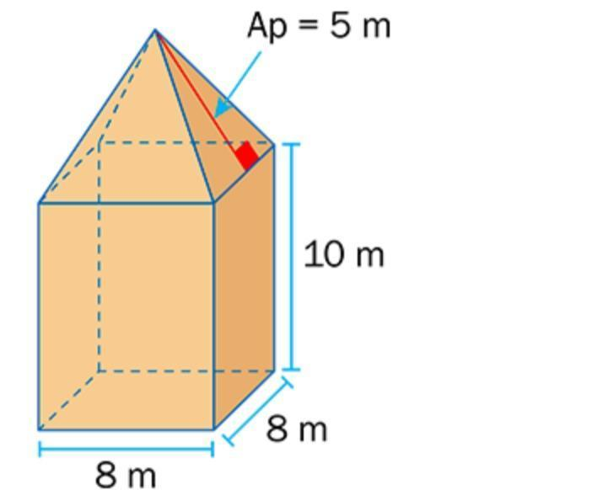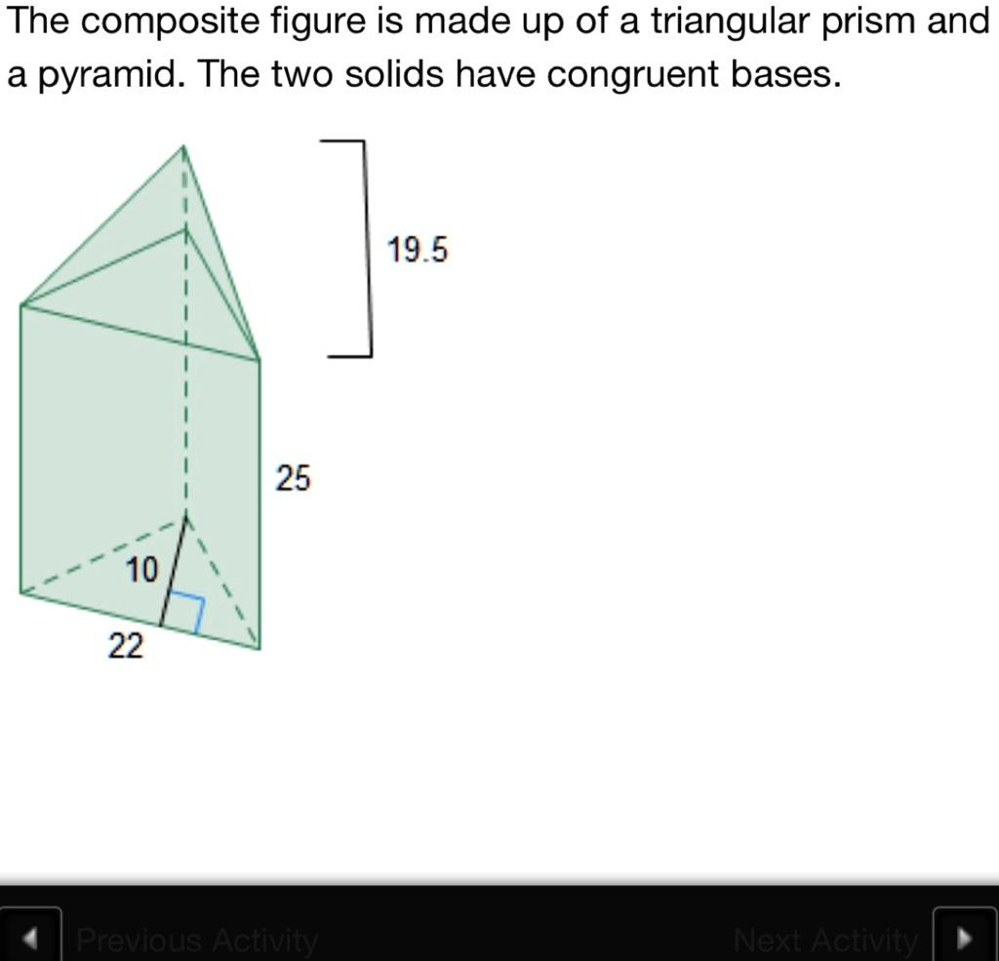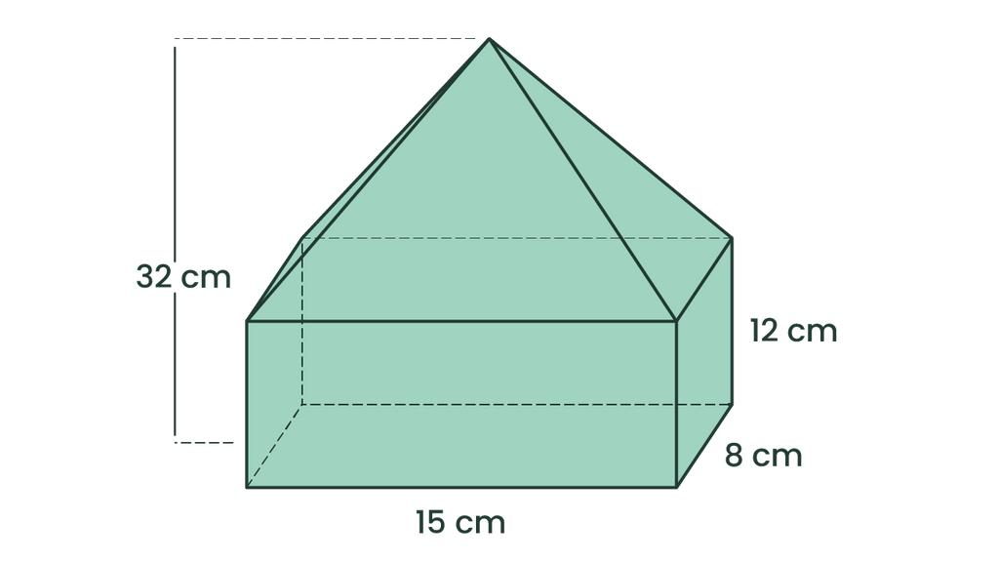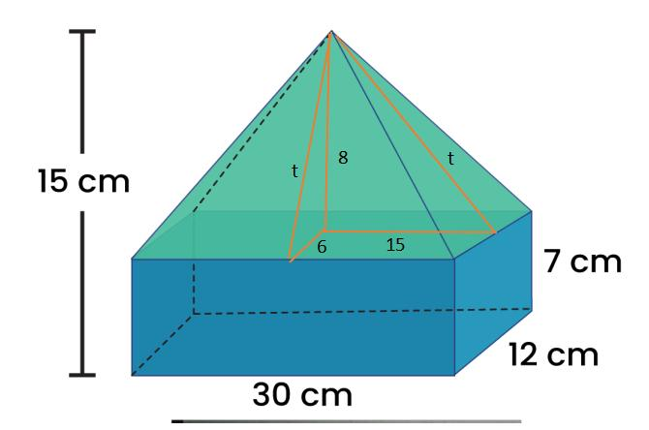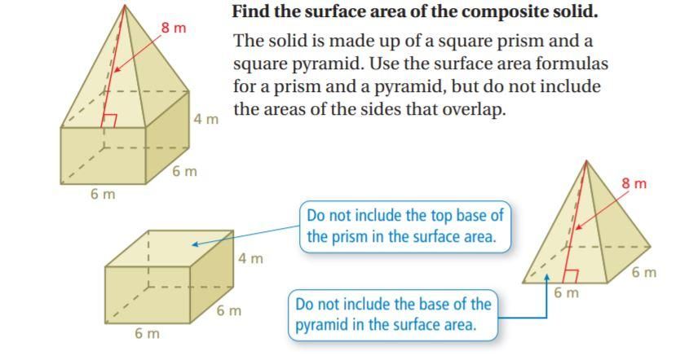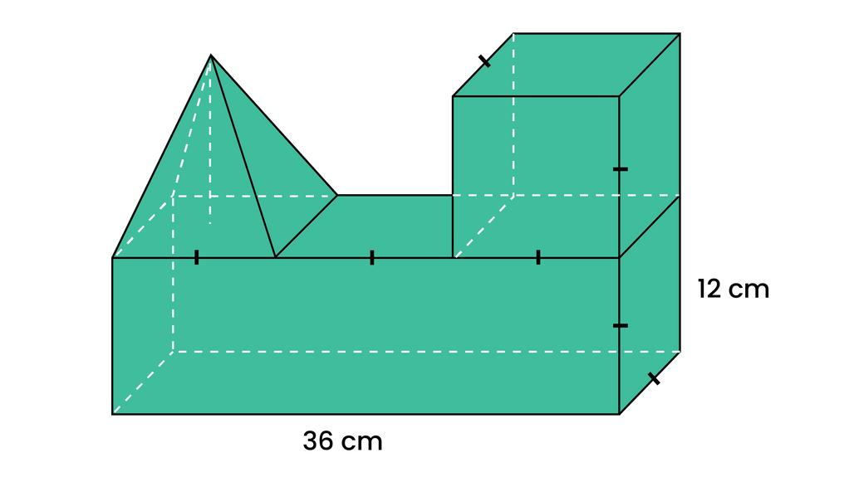
Formed by combining different types of prisms and pyramids.
Examples:
- Rectangular prism with a square pyramid.
- Triangular prism with a triangular pyramid.
- Square prism with multiple pyramids.
- Prism combined with different pyramid types.

Cylinder-Cone Composite Solids
# Source: AI Source: Provided by: [Data Path: Persons Table -> ID Column: 1, Name_En Column: Motasem Essam] -> From: [ChatGPT] on [7/25/2026]
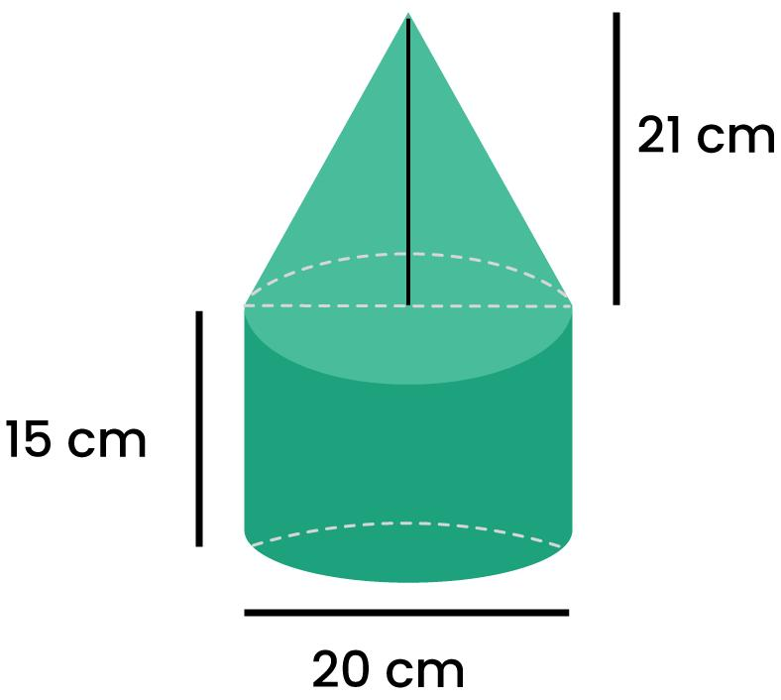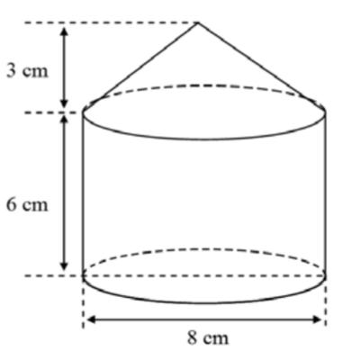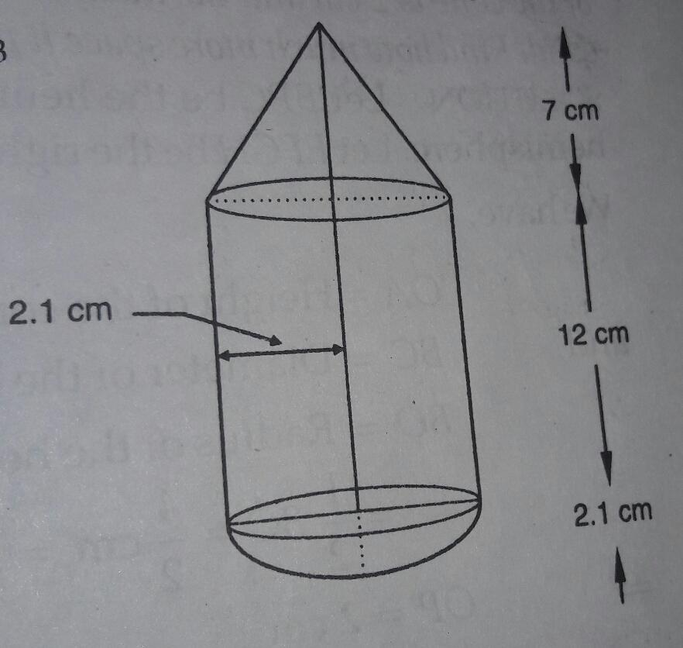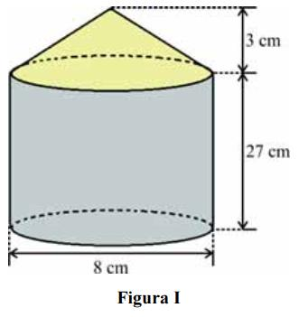
Formed by combining cylinders with one or more cones.
Examples:
- Cylinder with a cone on top.
- Cylinder with cones at both ends.
- Multiple cylinders and cones joined together.
- Cylinder with a cone and a frustum.

Cylinder-Sphere Composite Solids
# Source: AI Source: Provided by: [Data Path: Persons Table -> ID Column: 1, Name_En Column: Motasem Essam] -> From: [ChatGPT] on [7/25/2026]
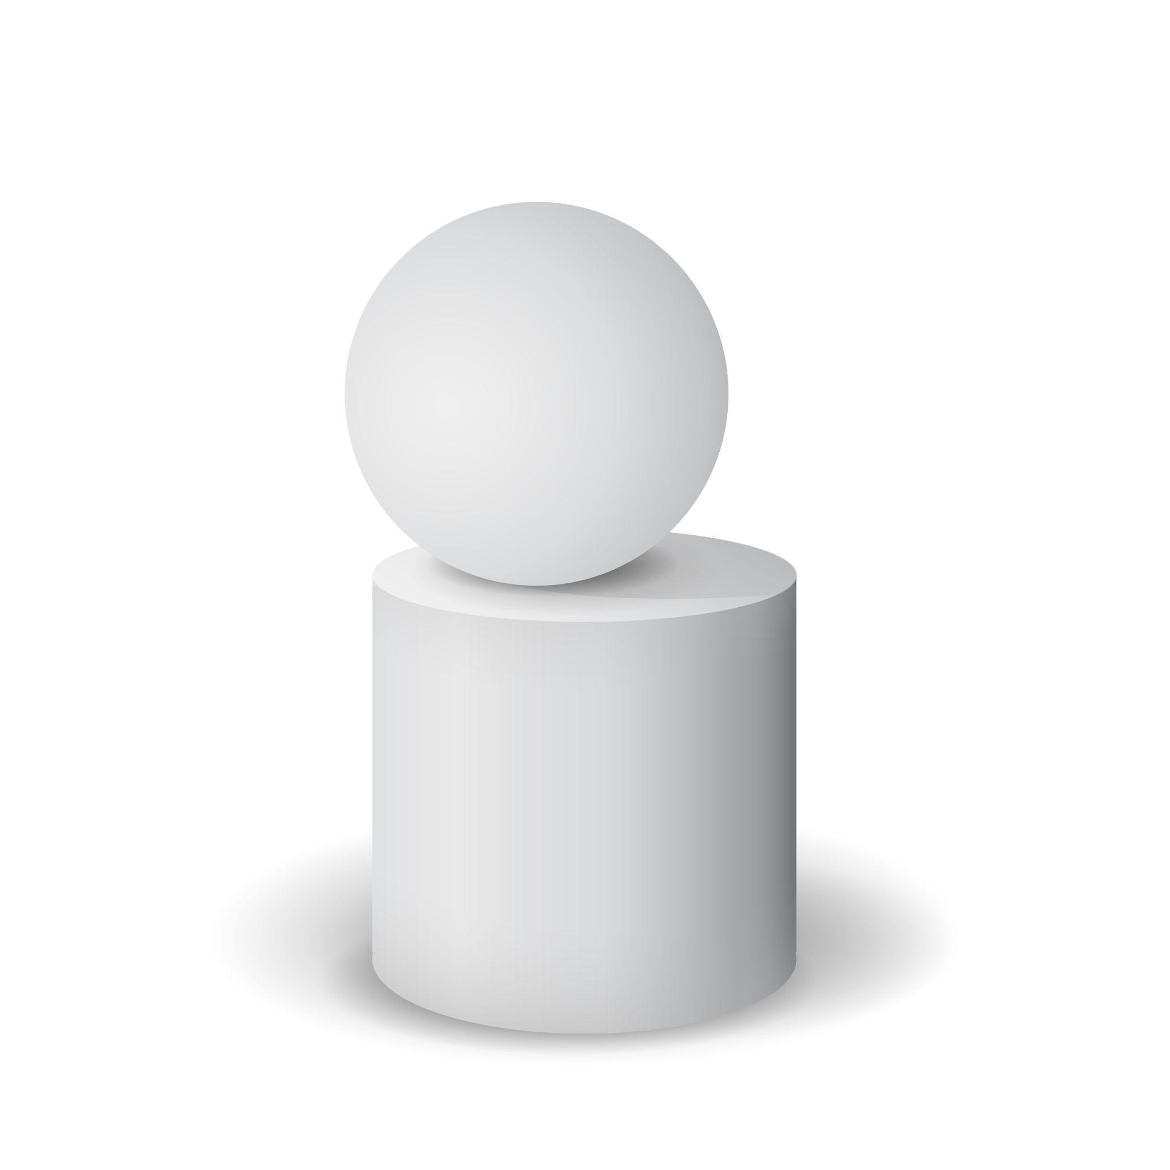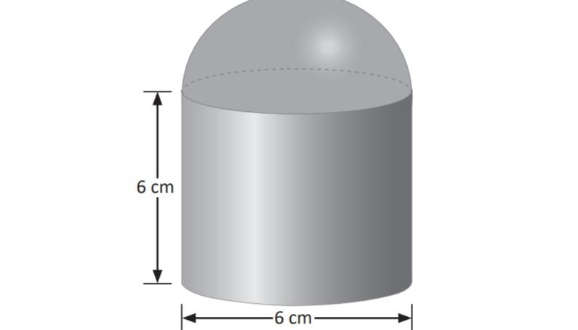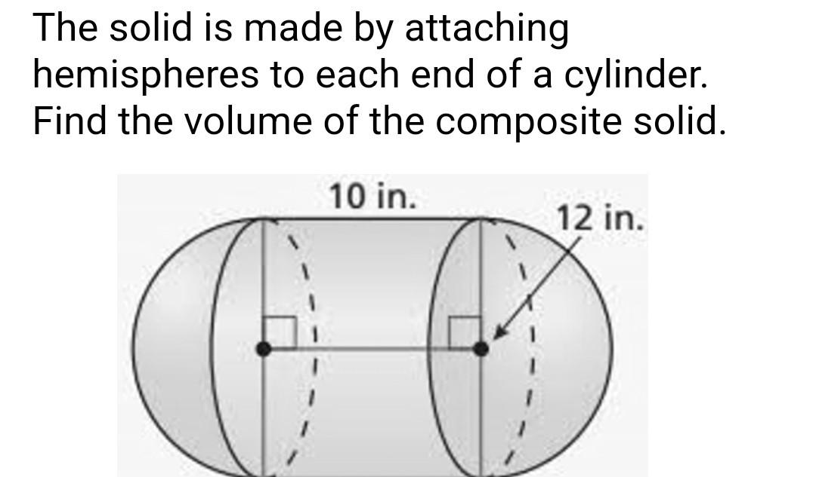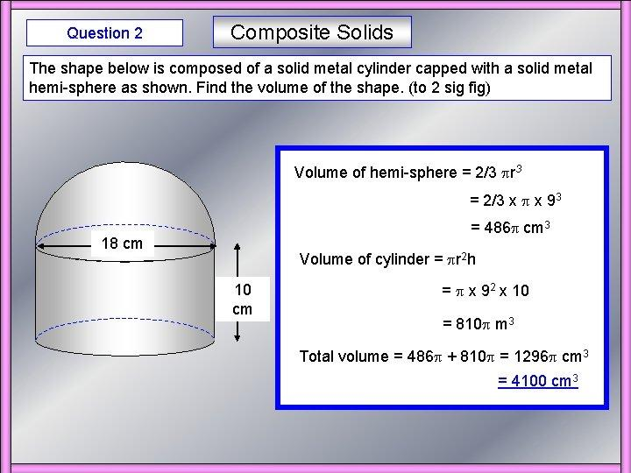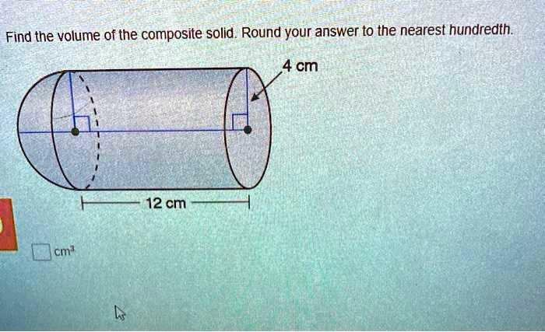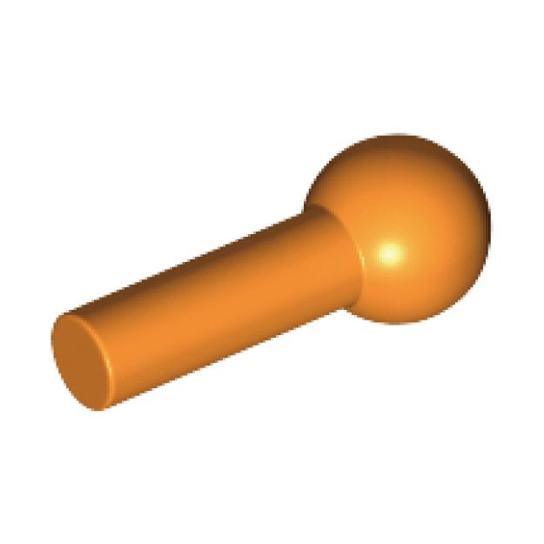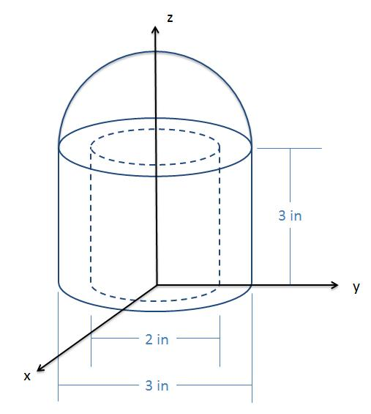
Formed by combining cylinders with spheres or sphere-derived components.
Examples:
- Cylinder with a sphere at one end.
- Cylinder with spheres at both ends.
- Cylinder with hemispherical ends.
- Multiple cylinders and spheres combined.

Cone-Pyramid Composite Solids
# Source: AI Source: Provided by: [Data Path: Persons Table -> ID Column: 1, Name_En Column: Motasem Essam] -> From: [ChatGPT] on [7/25/2026]
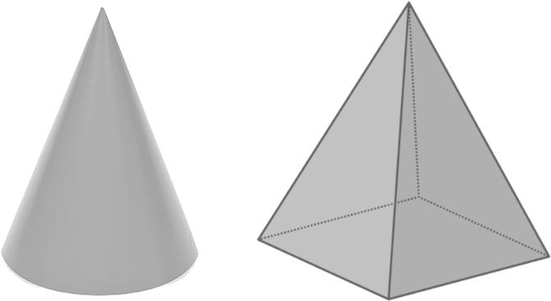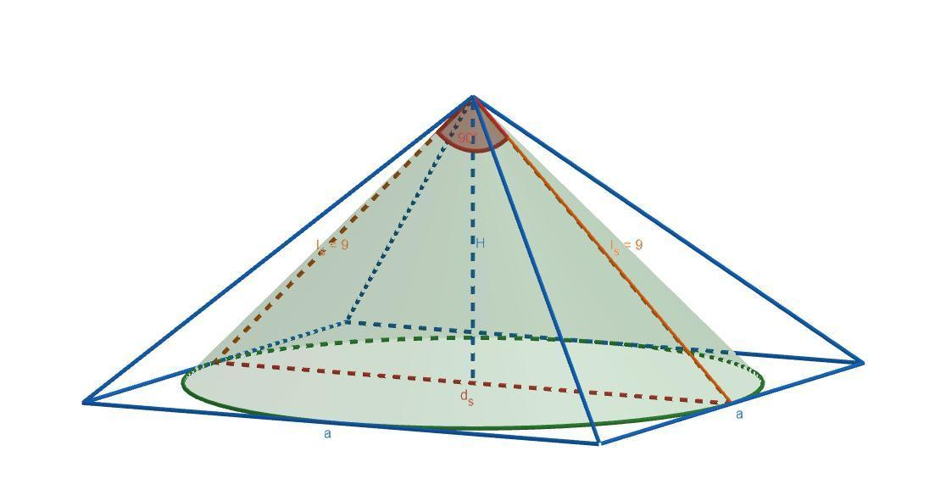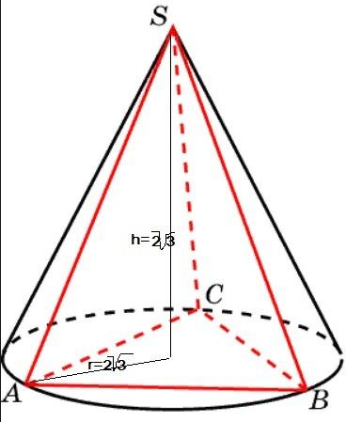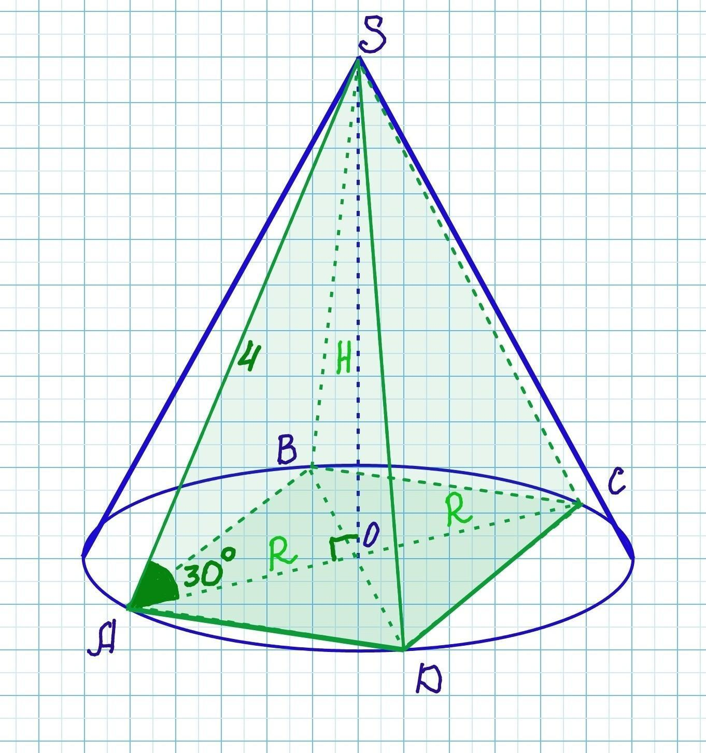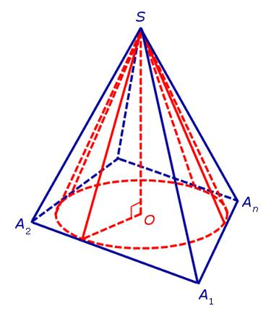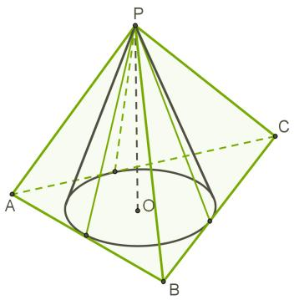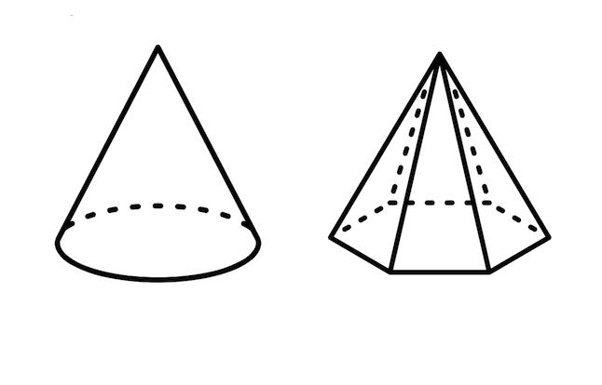
Formed by combining cones with one or more pyramids.
Examples:
- Cone with a square pyramid.
- Cone with a triangular pyramid.
- Multiple cones and pyramids combined.
- Cone attached to a pyramid-based structure.

Cone-Sphere Composite Solids
# Source: AI Source: Provided by: [Data Path: Persons Table -> ID Column: 1, Name_En Column: Motasem Essam] -> From: [ChatGPT] on [7/25/2026]
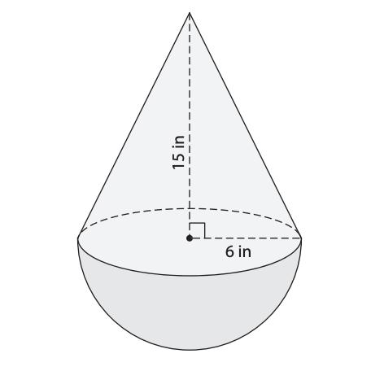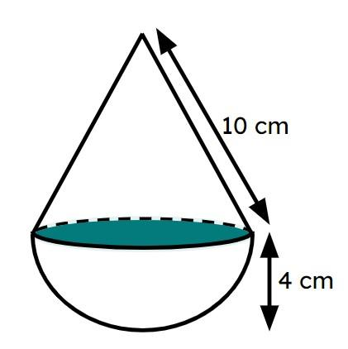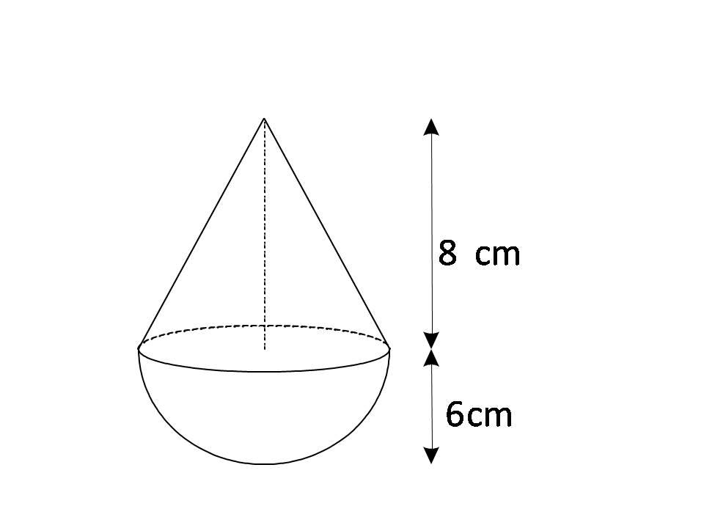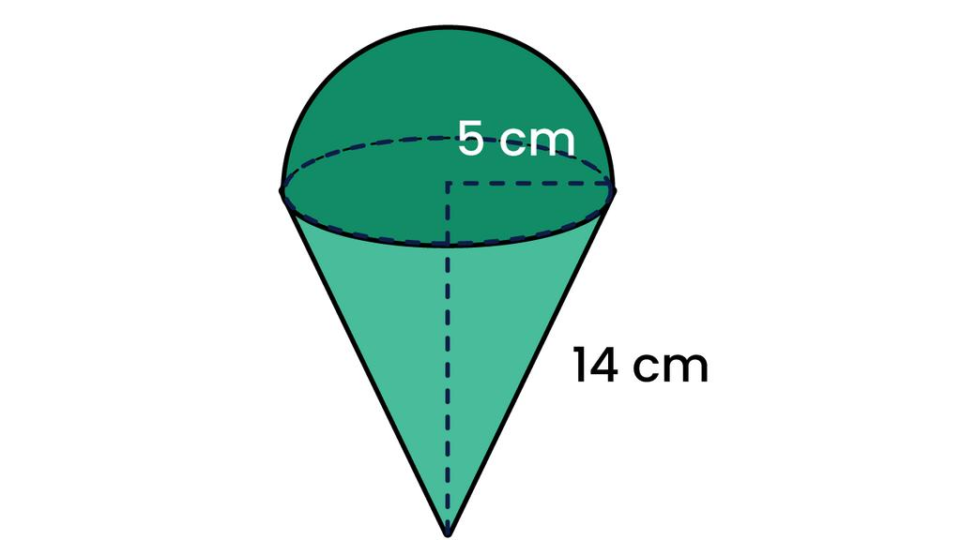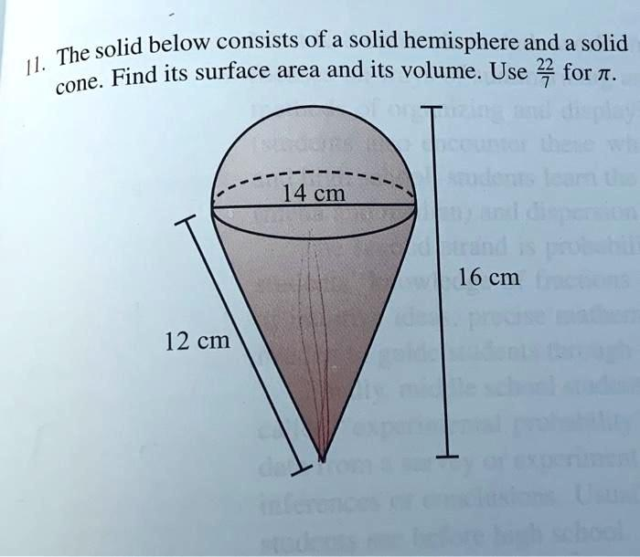
Formed by joining cones with spheres or hemispheres.
Examples:
- Cone with a sphere.
- Cone with a hemisphere.
- Cone with multiple spheres.
- Cone with a sphere and a frustum.

Pyramid-Sphere Composite Solids
# Source: AI Source: Provided by: [Data Path: Persons Table -> ID Column: 1, Name_En Column: Motasem Essam] -> From: [ChatGPT] on [7/25/2026]
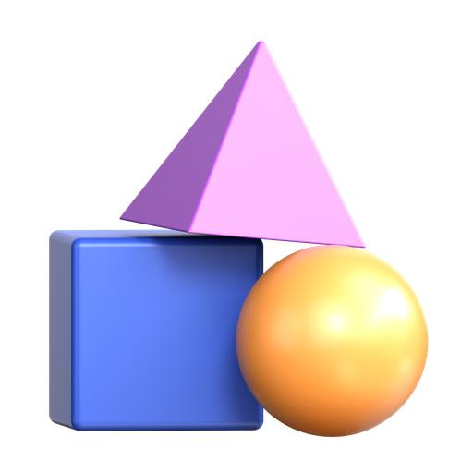
Formed by combining pyramids with spheres or hemispheres.
Examples:
- Square pyramid with a sphere.
- Triangular pyramid with a sphere.
- Pyramid with multiple hemispheres.
- Multiple pyramids combined with spherical components.

Multiple-Shape Composite Solids
# Source: AI Source: Provided by: [Data Path: Persons Table -> ID Column: 1, Name_En Column: Motasem Essam] -> From: [ChatGPT] on [7/25/2026]
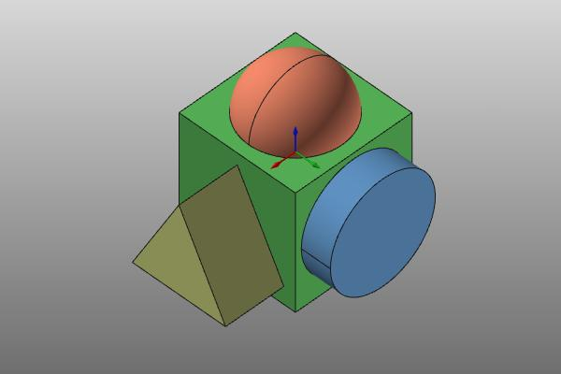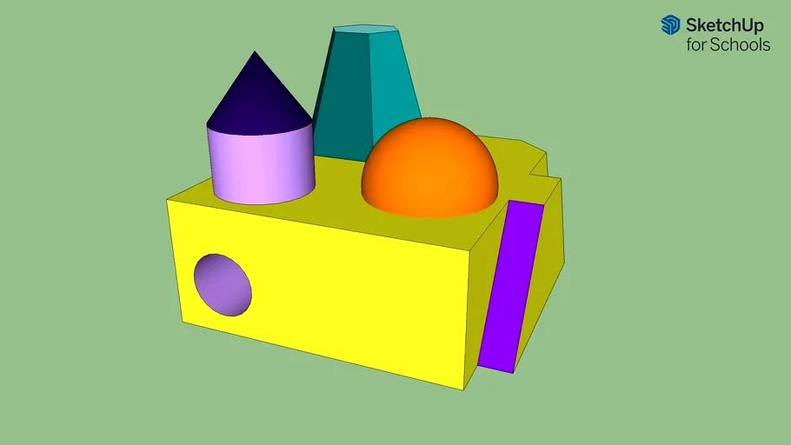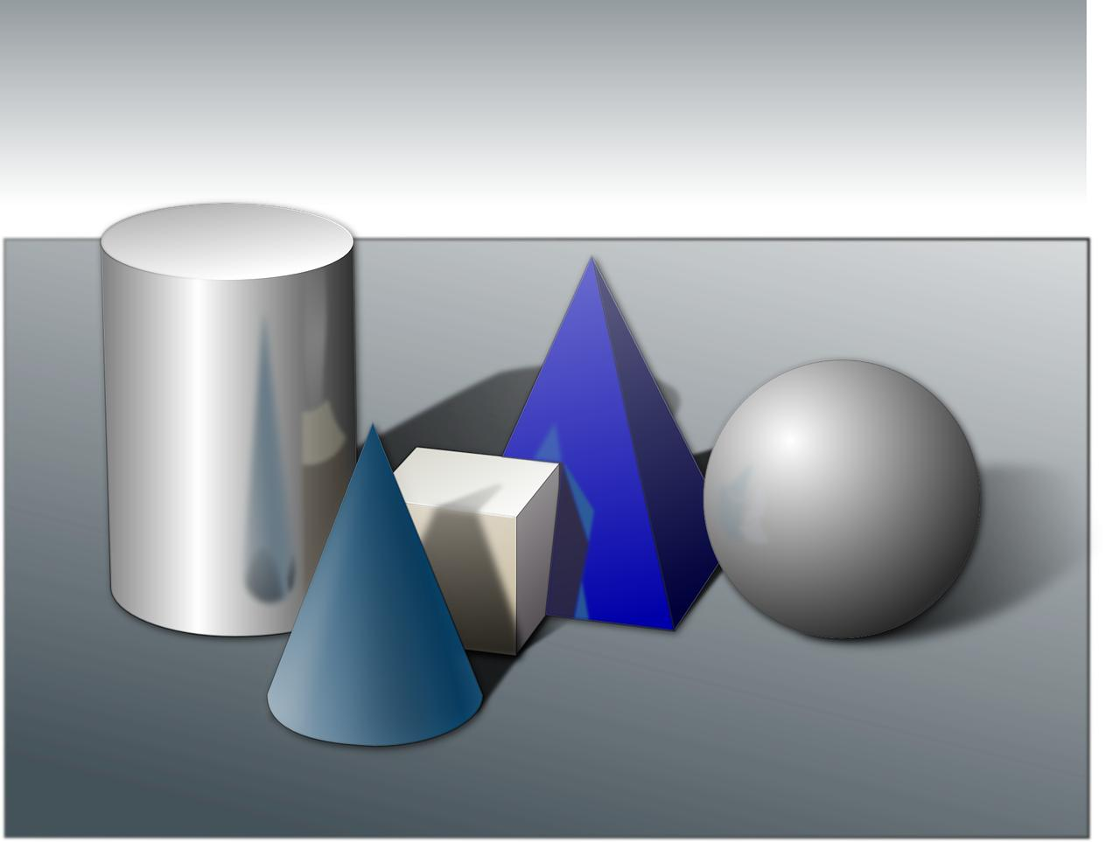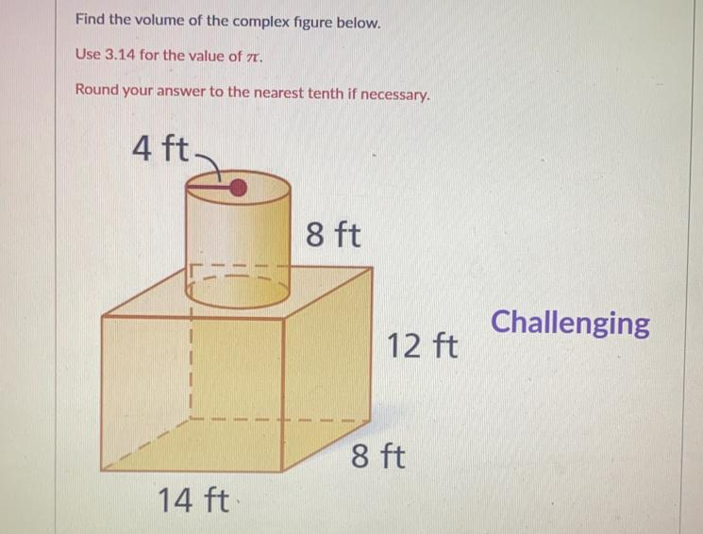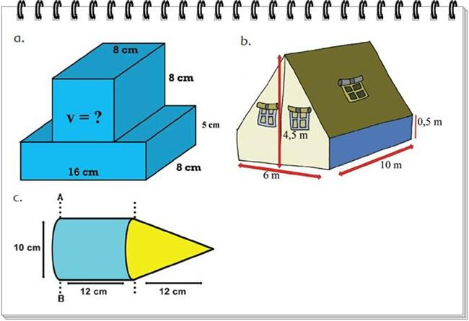
Formed by combining three or more different types of geometric solids.
Examples:
- Rectangular prism, cylinder, and cone.
- Cylinder, sphere, and pyramid.
- Prism, hemisphere, cone, and frustum.
- Multiple prisms, cylinders, cones, spheres, and pyramids.

Classification by Component Types
# Source: AI Source: Provided by: [Data Path: Persons Table -> ID Column: 1, Name_En Column: Motasem Essam] -> From: [ChatGPT] on [7/25/2026]
Mixed-shape composite solids can be classified according to the types and numbers of geometric solids used.
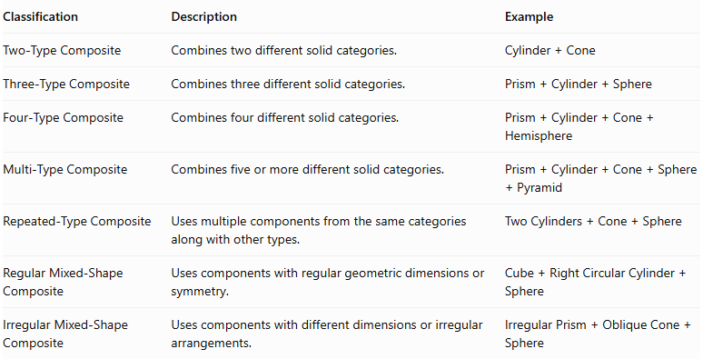
Classification | Description | Example
Two-Type Composite | Combines two different solid categories. | $$Cylinder+Cone$$
Three-Type Composite | Combines three different solid categories. | $$Prism+Cylinder+Sphere$$
Four-Type Composite | Combines four different solid categories. | $$Prism+Cylinder+Cone+Hemisphere$$
Multi-Type Composite | Combines five or more different solid categories. | $$Prism+Cylinder+Cone+Sphere+Pyramid$$
Repeated-Type Composite | Uses multiple components from the same categories along with other types. | $$TwoCylinders+Cone+Sphere$$
Regular Mixed-Shape Composite | Uses components with regular geometric dimensions or symmetry. | $$Cube+RightCircularCylinder+Sphere$$
Irregular Mixed-Shape Composite | Uses components with different dimensions or irregular arrangements. | $$IrregularPrism+ObliqueCone+Sphere$$

Classification by Arrangement
# Source: AI Source: Provided by: [Data Path: Persons Table -> ID Column: 1, Name_En Column: Motasem Essam] -> From: [ChatGPT] on [7/25/2026]
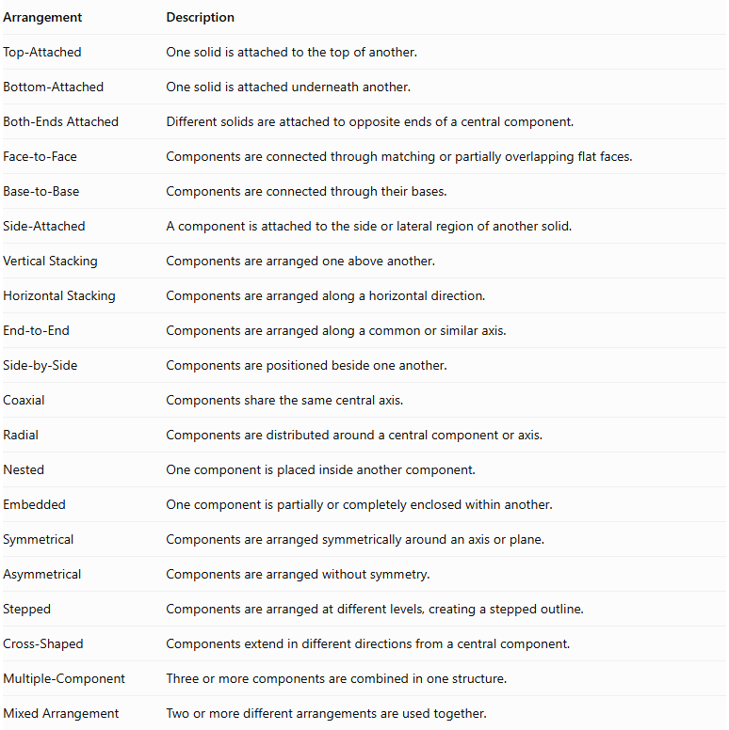
Arrangement | Description
Top-Attached | One solid is attached to the top of another.
Bottom-Attached | One solid is attached underneath another.
Both-Ends Attached | Different solids are attached to opposite ends of a central component.
Face-to-Face | Components are connected through matching or partially overlapping flat faces.
Base-to-Base | Components are connected through their bases.
Side-Attached | A component is attached to the side or lateral region of another solid.
Vertical Stacking | Components are arranged one above another.
Horizontal Stacking | Components are arranged along a horizontal direction.
End-to-End | Components are arranged along a common or similar axis.
Side-by-Side | Components are positioned beside one another.
Coaxial | Components share the same central axis.
Radial | Components are distributed around a central component or axis.
Nested | One component is placed inside another component.
Embedded | One component is partially or completely enclosed within another.
Symmetrical | Components are arranged symmetrically around an axis or plane.
Asymmetrical | Components are arranged without symmetry.
Stepped | Components are arranged at different levels, creating a stepped outline.
Cross-Shaped | Components extend in different directions from a central component.
Multiple-Component | Three or more components are combined in one structure.
Mixed Arrangement | Two or more different arrangements are used together.
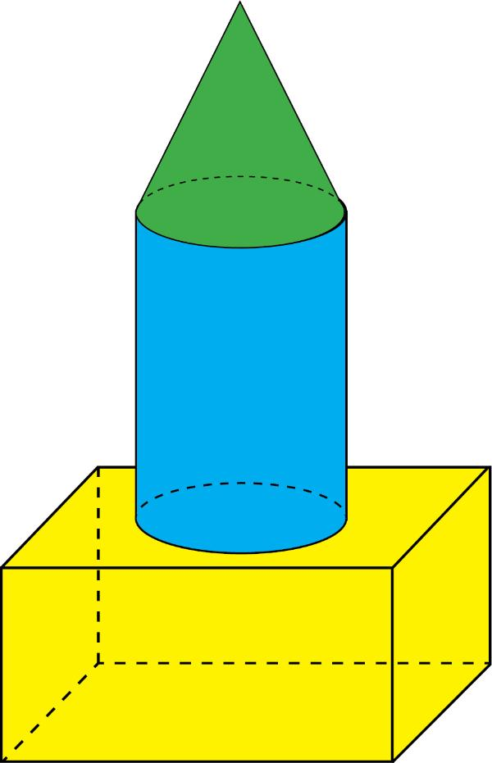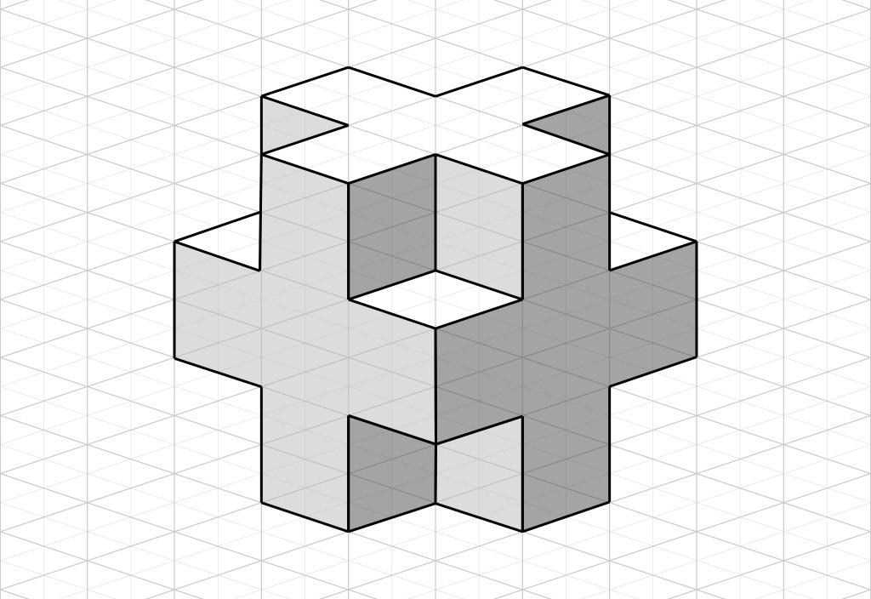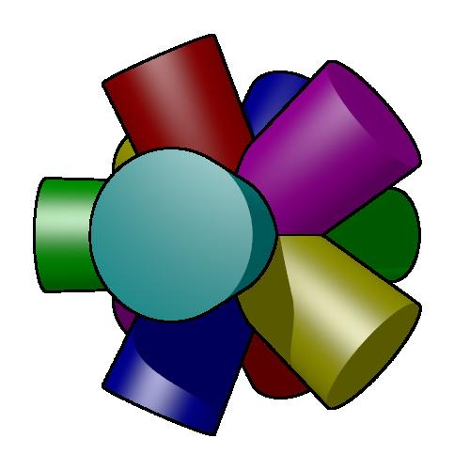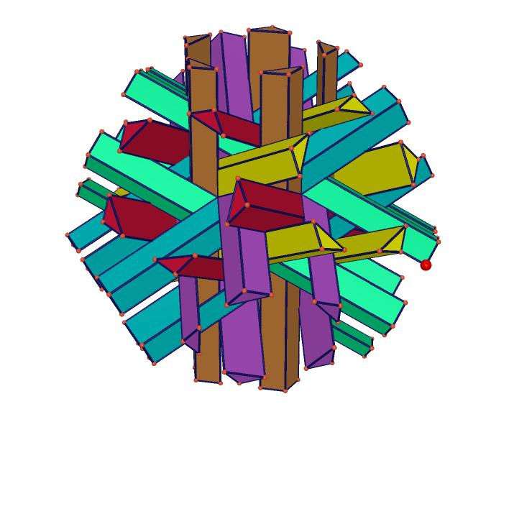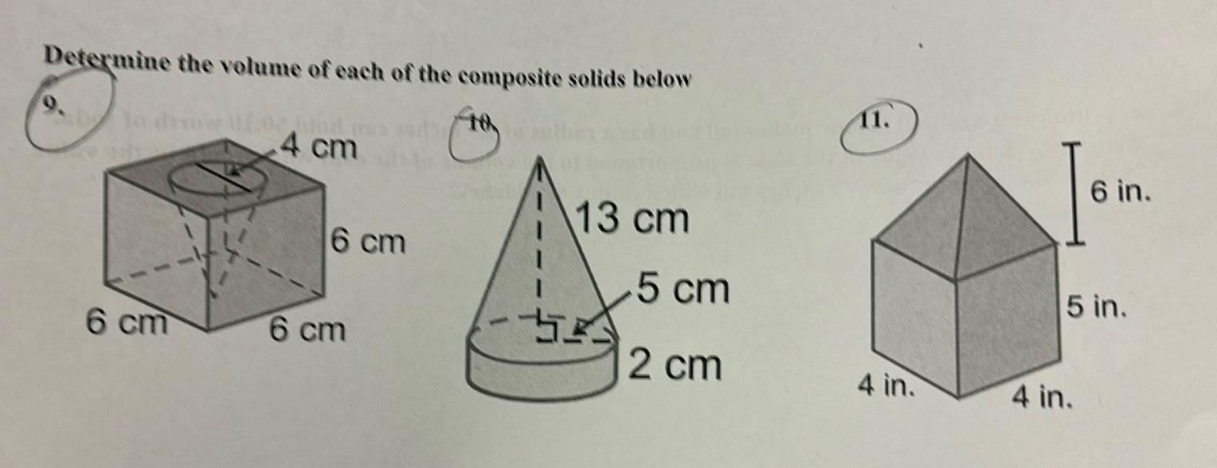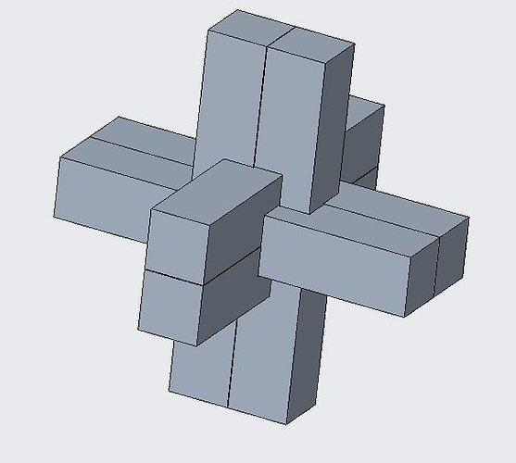

Classification by Surface Combination
# Source: AI Source: Provided by: [Data Path: Persons Table -> ID Column: 1, Name_En Column: Motasem Essam] -> From: [ChatGPT] on [7/25/2026]
Mixed-shape composite solids can also be classified according to the types of external surfaces they contain.
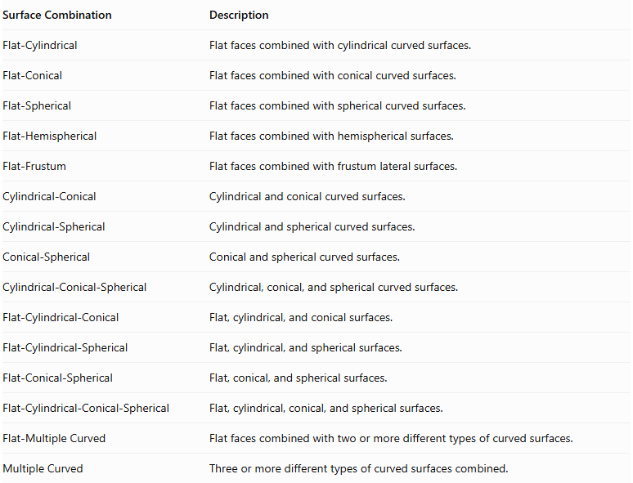
Surface Combination | Description
Flat-Cylindrical | Flat faces combined with cylindrical curved surfaces.
Flat-Conical | Flat faces combined with conical curved surfaces.
Flat-Spherical | Flat faces combined with spherical curved surfaces.
Flat-Hemispherical | Flat faces combined with hemispherical surfaces.
Flat-Frustum | Flat faces combined with frustum lateral surfaces.
Cylindrical-Conical | Cylindrical and conical curved surfaces.
Cylindrical-Spherical | Cylindrical and spherical curved surfaces.
Conical-Spherical | Conical and spherical curved surfaces.
Cylindrical-Conical-Spherical | Cylindrical, conical, and spherical curved surfaces.
Flat-Cylindrical-Conical | Flat, cylindrical, and conical surfaces.
Flat-Cylindrical-Spherical | Flat, cylindrical, and spherical surfaces.
Flat-Conical-Spherical | Flat, conical, and spherical surfaces.
Flat-Cylindrical-Conical-Spherical | Flat, cylindrical, conical, and spherical surfaces.
Flat-Multiple Curved | Flat faces combined with two or more different types of curved surfaces.
Multiple Curved | Three or more different types of curved surfaces combined.
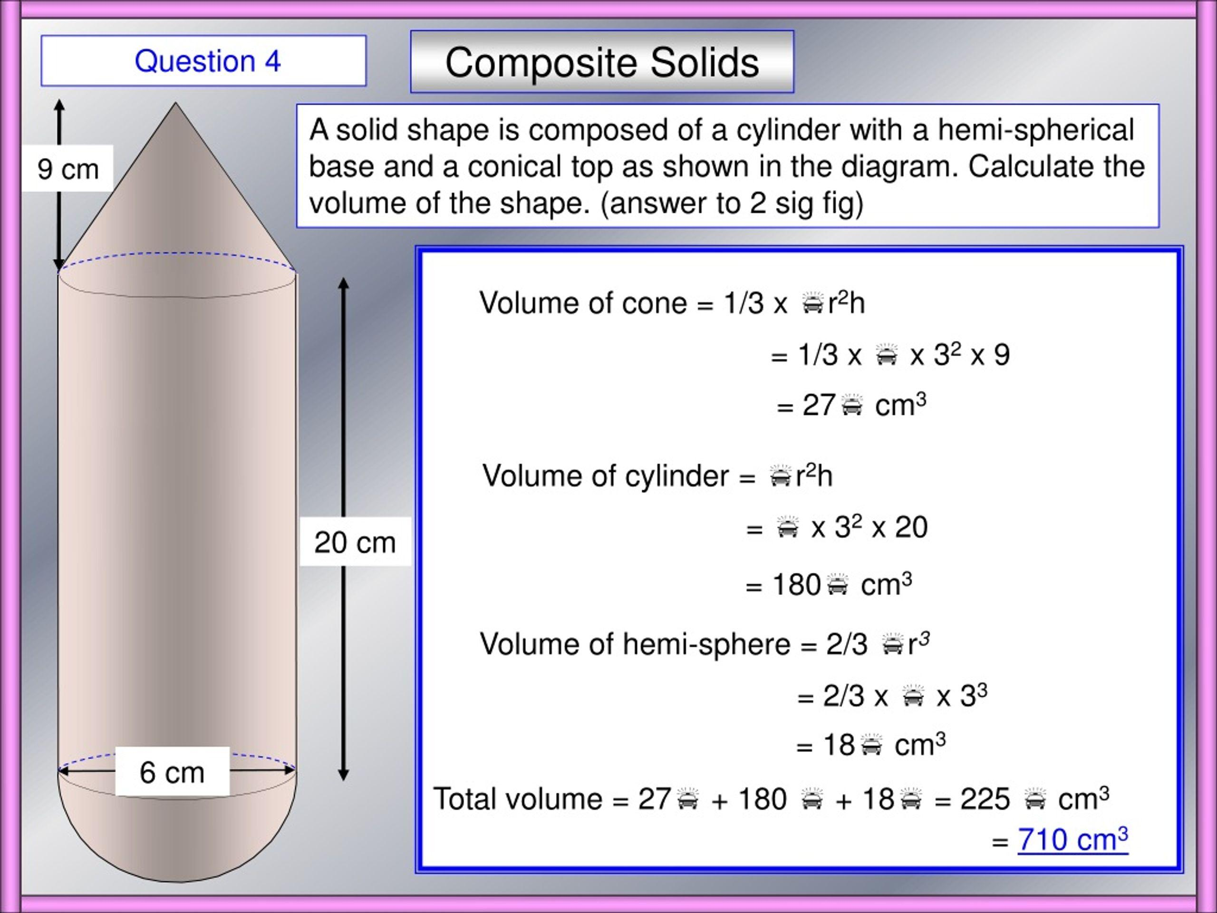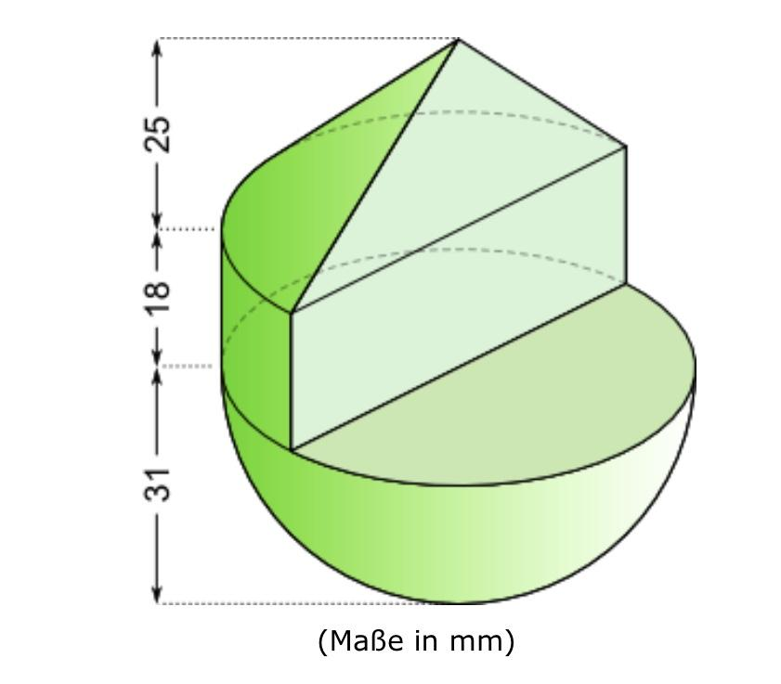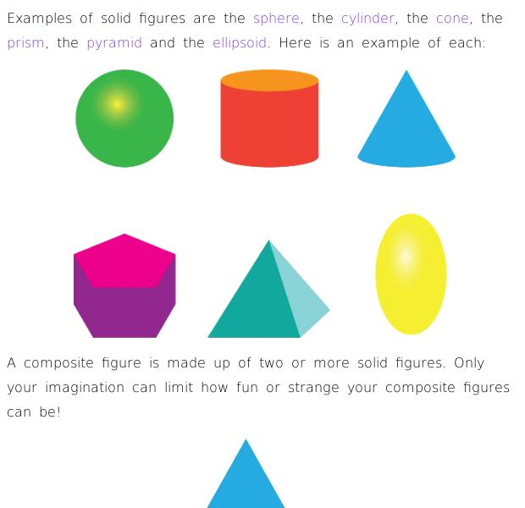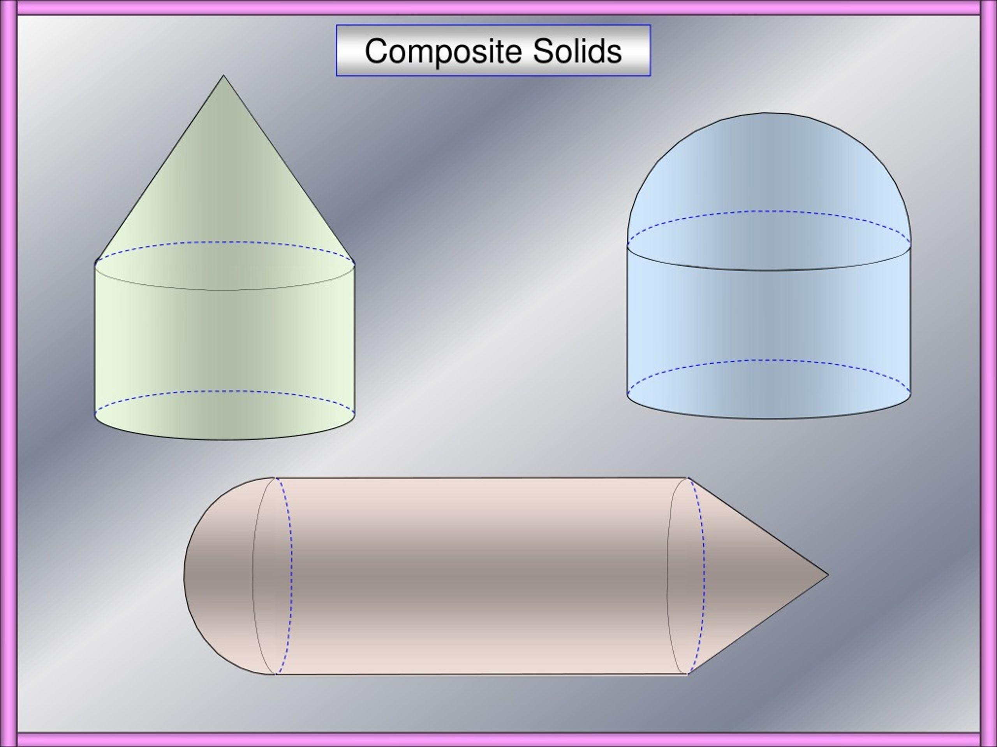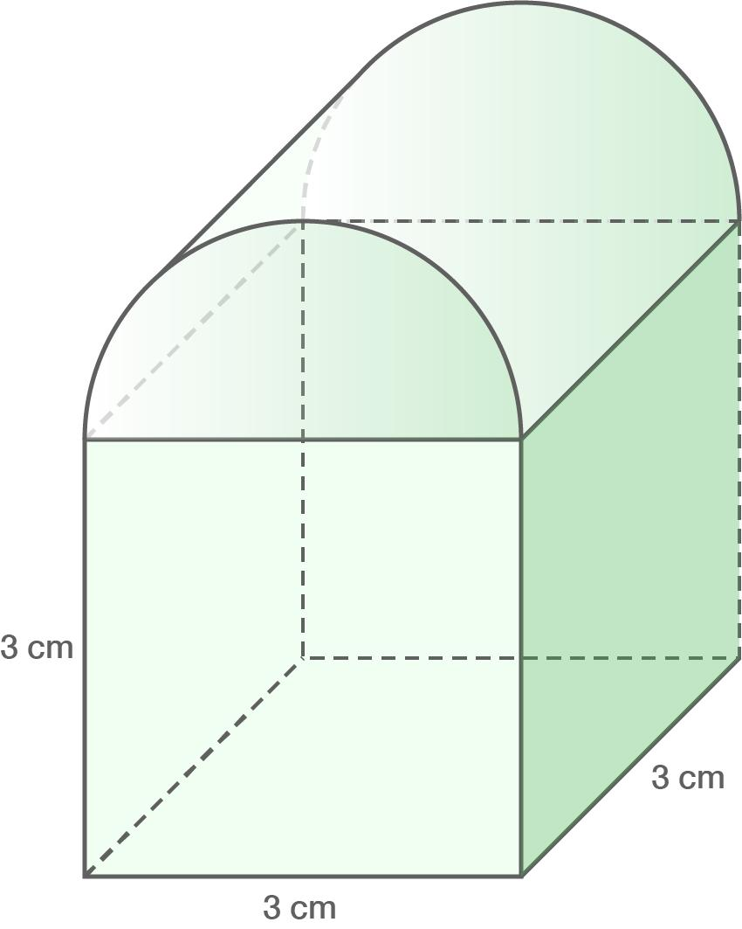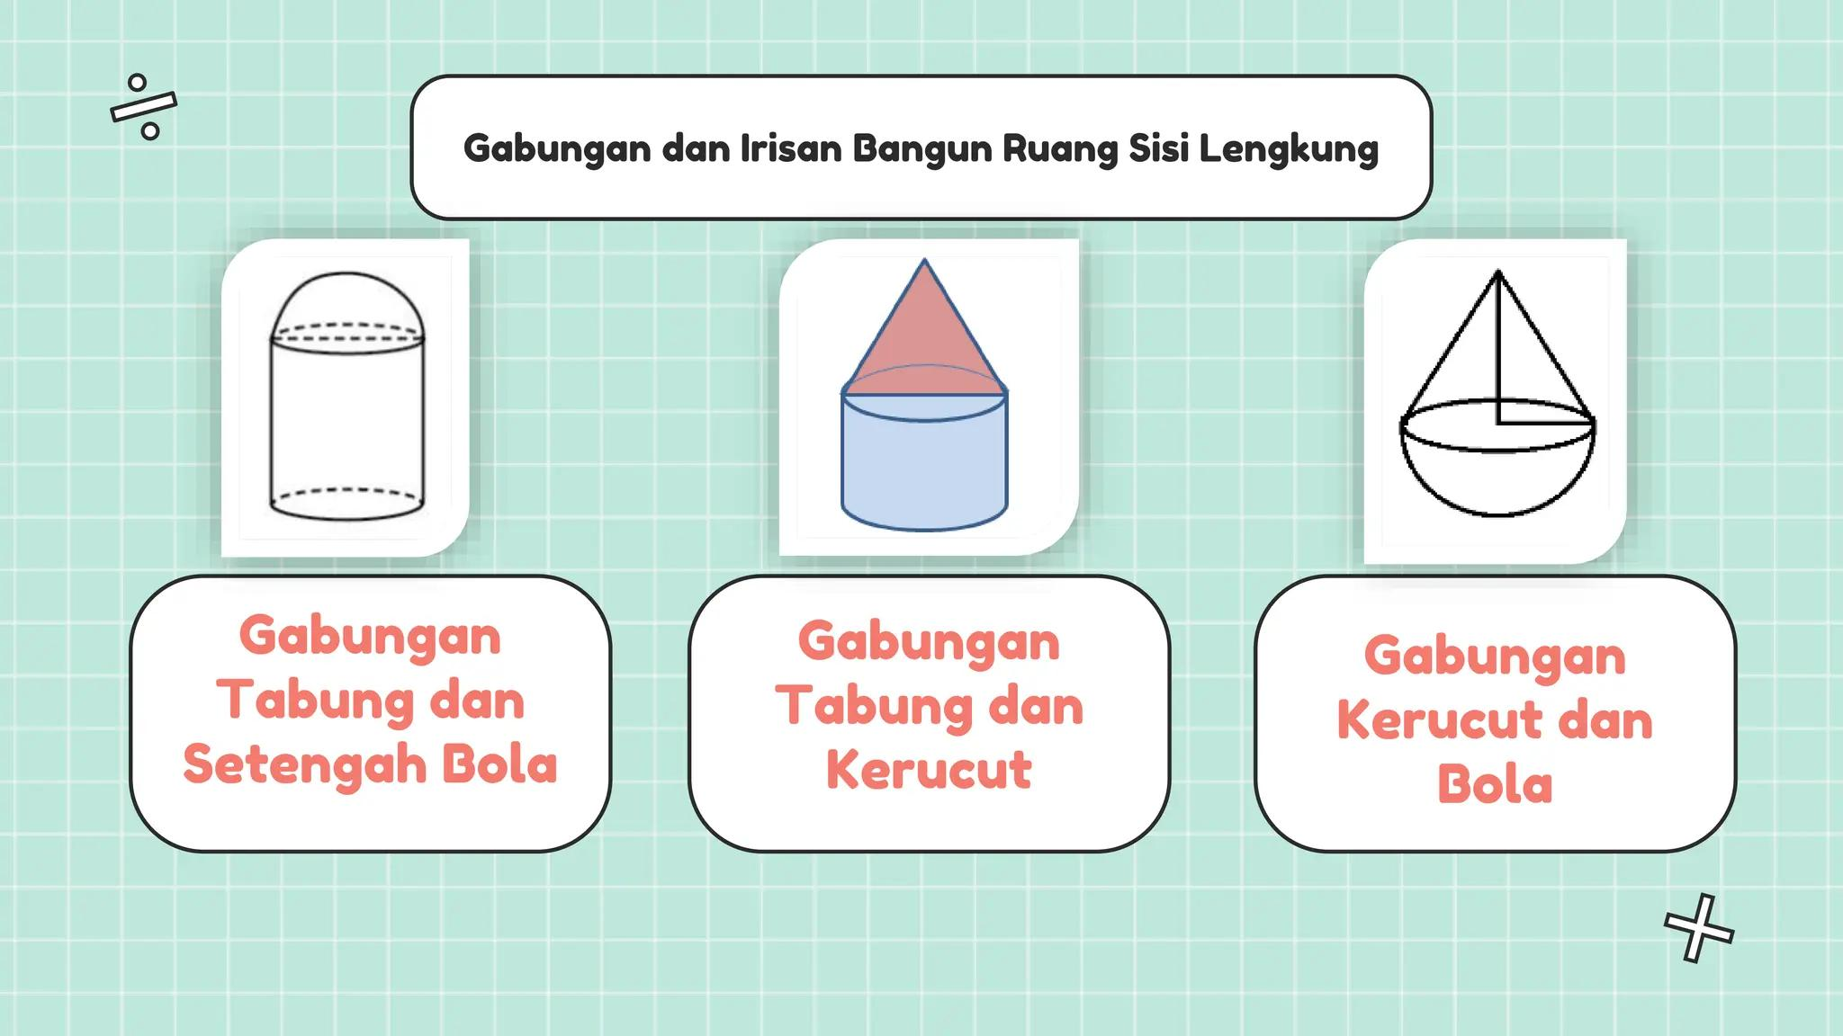

Mathematical Properties and Formulas

Volume
# Source: AI Source: Provided by: [Data Path: Persons Table -> ID Column: 1, Name_En Column: Motasem Essam] -> From: [ChatGPT] on [7/25/2026]
The total volume of a mixed-shape composite solid is calculated by combining the volumes of its individual components.
For components with no overlapping interiors:
$$V_{total}=V_{1}+V_{2}+⋯+V_{n}$$
For two overlapping components:
$$V_{union}=V_{1}+V_{2}-V_{overlap}$$
For more complex arrangements, all overlapping regions must be accounted for.
Important volume formulas:
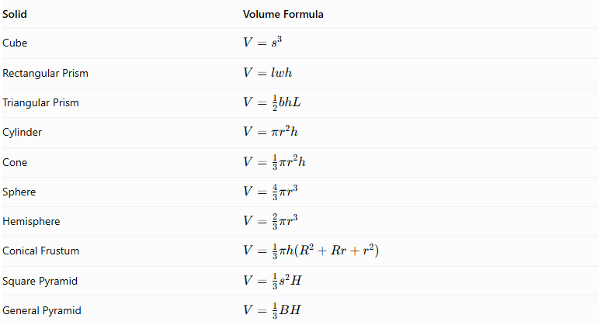
Solid | Volume Formula
Cube | $$V=s^{3}$$
Rectangular Prism | $$V=lwh$$
Triangular Prism | $$V=\frac{1}{2}bhL$$
Cylinder | $$V=πr^{2}h$$
Cone | $$V=\frac{1}{3}πr^{2}h$$
Sphere | $$V=\frac{4}{3}πr^{3}$$
Hemisphere | $$V=\frac{2}{3}πr^{3}$$
Conical Frustum | $$V=\frac{1}{3}πh(R^{2}+Rr+r^{2})$$
Square Pyramid | $$V=\frac{1}{3}s^{2}H$$
General Pyramid | $$V=\frac{1}{3}BH$$
Where:
- $s$ = side length of a cube or square base.
- $l$ = length of a rectangular prism.
- $w$ = width of a rectangular prism.
- $h$ = perpendicular height.
- $b$ = triangular base width.
- $L$ = length of a triangular prism.
- $r$ = radius.
- $R$ = larger radius of a frustum.
- $H$ = perpendicular height of a pyramid.
- $B$ = area of a pyramid's base.

Surface Area
# Source: AI Source: Provided by: [Data Path: Persons Table -> ID Column: 1, Name_En Column: Motasem Essam] -> From: [ChatGPT] on [7/25/2026]
The external surface area is the sum of the exposed surfaces of all components.
For two components joined through a complete matching planar face:
$${SA}_{external}={SA}_{1}+{SA}_{2}-2A_{joining}$$
For partial contact, only the actual hidden contact areas should be excluded.
For multiple components, every hidden interface must be accounted for. Curved intersections and overlapping components may require more detailed geometric calculations.
Important surface-area formulas:
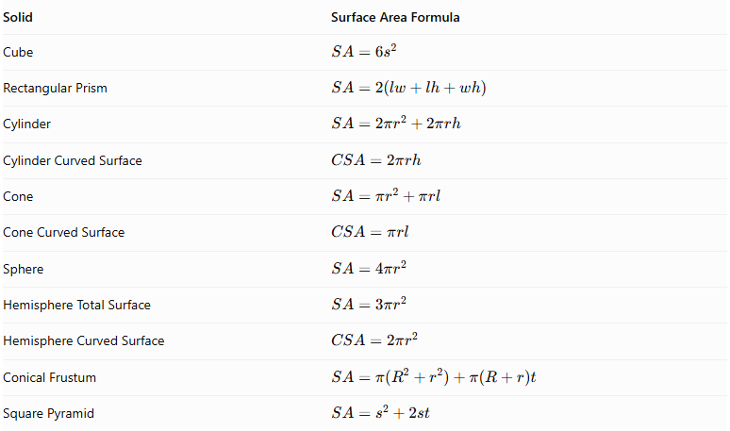
Solid | Surface Area Formula
Cube | $$SA=6s^{2}$$
Rectangular Prism | $$SA=2(lw+lh+wh)$$
Cylinder | $$SA=2πr^{2}+2πrh$$
Cylinder Curved Surface | $$CSA=2πrh$$
Cone | $$SA=πr^{2}+πrl$$
Cone Curved Surface | $$CSA=πrl$$
Sphere | $$SA=4πr^{2}$$
Hemisphere Total Surface | $$SA=3πr^{2}$$
Hemisphere Curved Surface | $$CSA=2πr^{2}$$
Conical Frustum | $$SA=π(R^{2}+r^{2})+π(R+r)t$$
Square Pyramid | $$SA=s^{2}+2st$$
Here, $t$ represents the slant height of the frustum or square pyramid, as appropriate.
For a right circular cone:
$$l=\sqrt{r^{2}+h^{2}}$$
For a right circular conical frustum:
$$t=\sqrt{h^{2}+(R-r)^{2}}$$

Important Surface-Area Considerations
# Source: AI Source: Provided by: [Data Path: Persons Table -> ID Column: 1, Name_En Column: Motasem Essam] -> From: [ChatGPT] on [7/25/2026]
- Only exposed surfaces contribute to the external surface area.
- Complete joining faces become hidden and must be excluded.
- Partial joining regions require subtracting only the actual contact area from each affected component.
- A curved component attached to a flat face may cover only part of that face.
- Components that intersect or overlap may require calculating the actual intersection boundary.
- A sphere touching another solid at a single point does not create a joining surface with positive area.
- The surface area of a mixed-shape composite solid is not necessarily the sum of the complete surface areas of its components.

Worked Examples

Example 1: Cylinder with a Cone and a Hemisphere
# Source: AI Source: Provided by: [Data Path: Persons Table -> ID Column: 1, Name_En Column: Motasem Essam] -> From: [ChatGPT] on [7/25/2026]
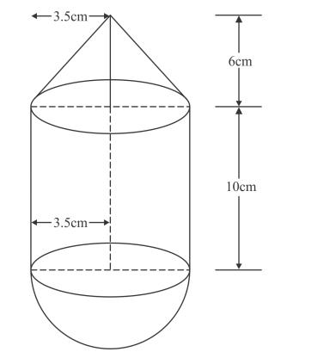
Given:
A composite solid consists of a cylinder with a cone attached to its top and a hemisphere attached to its bottom.
All three components have the same radius.
- Radius = 3 cm.
- Cylinder height = 8 cm.
- Cone height = 4 cm.
- Hemisphere radius = 3 cm.
Find the total volume and external surface area.
Step 1: Calculate the cylinder volume.
$$V_{c}=πr^{2}h$$
$$V_{c}=π(3)^{2}(8)=72π$$
Step 2: Calculate the cone volume.
$$V_{cone}=\frac{1}{3}πr^{2}h$$
$$V_{cone}=\frac{1}{3}π(3)^{2}(4)=12π$$
Step 3: Calculate the hemisphere volume.
$$V_{hemisphere}=\frac{2}{3}πr^{3}$$
$$V_{hemisphere}=\frac{2}{3}π(3)^{3}=18π$$
Step 4: Calculate the total volume.
$$V_{total}=72π+12π+18π$$
$$\boxed{V_{total}=102π≈320.44{ cm}^{3}}$$
Step 5: Calculate the cylinder's exposed surface area.
Both circular bases are hidden by the cone and hemisphere. Only the curved surface is exposed.
$${CSA}_{c}=2πrh$$
$${CSA}_{c}=2π(3)(8)=48π$$
Step 6: Calculate the cone's curved surface area.
First, calculate its slant height:
$$l=\sqrt{r^{2}+h^{2}}$$
$$l=\sqrt{3^{2}+4^{2}}=5$$
Then:
$${CSA}_{cone}=πrl$$
$${CSA}_{cone}=π(3)(5)=15π$$
Step 7: Calculate the hemisphere's curved surface area.
$${CSA}_{hemisphere}=2πr^{2}$$
$${CSA}_{hemisphere}=2π(3)^{2}=18π$$
Step 8: Calculate the total external surface area.
$${SA}_{total}=48π+15π+18π$$
$$\boxed{{SA}_{total}=81π≈254.47{ cm}^{2}}$$
<badge color="success">Final Answer</badge>
- Total Volume = $102π≈320.44{ cm}^{3}$
- External Surface Area = $81π≈254.47{ cm}^{2}$

Example 2: Rectangular Prism with a Cylinder and a Cone
# Source: AI Source: Provided by: [Data Path: Persons Table -> ID Column: 1, Name_En Column: Motasem Essam] -> From: [ChatGPT] on [7/25/2026]
Given:
A composite solid consists of:
- A rectangular prism at the bottom.
- A cylinder attached to the top face of the prism.
- A cone attached to the top of the cylinder.
Rectangular prism:
- Length = 10 cm.
- Width = 8 cm.
- Height = 6 cm.
Cylinder:
- Radius = 2 cm.
- Height = 5 cm.
Cone:
- Radius = 2 cm.
- Height = 3 cm.
The circular bases of the cylinder and cone match, and the cylinder's bottom circular base lies entirely within the prism's top face.
Find the total volume and external surface area.
Step 1: Calculate the rectangular prism volume.
$$V_{p}=lwh$$
$$V_{p}=10(8)(6)=480$$
Step 2: Calculate the cylinder volume.
$$V_{c}=πr^{2}h$$
$$V_{c}=π(2)^{2}(5)=20π$$
Step 3: Calculate the cone volume.
$$V_{cone}=\frac{1}{3}πr^{2}h$$
$$V_{cone}=\frac{1}{3}π(2)^{2}(3)=4π$$
Step 4: Calculate the total volume.
$$V_{total}=480+20π+4π$$
$$\boxed{V_{total}=480+24π≈555.40{ cm}^{3}}$$
Step 5: Calculate the rectangular prism surface area.
$${SA}_{p}=2(lw+lh+wh)$$
$${SA}_{p}=2(10(8)+10(6)+8(6))$$
$${SA}_{p}=2(80+60+48)=376$$
The circular contact region covered by the cylinder is:
$$A_{joining}=πr^{2}=4π$$
Therefore, the exposed prism surface area is:
$${SA}_{p,exposed}=376-4π$$
Step 6: Calculate the cylinder's exposed curved surface area.
Its bottom and top circular bases are both hidden.
$${CSA}_{c}=2πrh$$
$${CSA}_{c}=2π(2)(5)=20π$$
Step 7: Calculate the cone's curved surface area.
First, calculate its slant height:
$$l=\sqrt{r^{2}+h^{2}}$$
$$l=\sqrt{2^{2}+3^{2}}=\sqrt{13}$$
Then:
$${CSA}_{cone}=πrl$$
$${CSA}_{cone}=2π\sqrt{13}$$
Step 8: Calculate the total external surface area.
$${SA}_{total}=(376-4π)+20π+2π\sqrt{13}$$
$$\boxed{{SA}_{total}=376+16π+2π\sqrt{13}≈448.92{ cm}^{2}}$$
<badge color="success">Final Answer</badge>
- Total Volume = $480+24π≈555.40{ cm}^{3}$
- External Surface Area = $376+16π+2π\sqrt{13}≈448.92{ cm}^{2}$

Important Characteristics
# Source: AI Source: Provided by: [Data Path: Persons Table -> ID Column: 1, Name_En Column: Motasem Essam] -> From: [ChatGPT] on [7/25/2026]
- Multiple Solid Categories: A mixed-shape composite solid contains two or more different types of geometric solids.
- Flat and Curved Surfaces: Its external boundary can contain polygonal faces and different types of curved surfaces.
- Flexible Component Selection: Components can include prisms, cylinders, cones, spheres, hemispheres, pyramids, and frustums.
- Different Arrangements: Components can be stacked, attached side-by-side, arranged radially, embedded, or combined in other configurations.
- Multiple Components: A structure may contain two, three, four, or more different solid types.
- Hidden Joining Surfaces: Joining regions become internal and must be excluded from external surface-area calculations.
- Volume Combination: Component volumes can be added when their interiors do not overlap.
- Complex External Boundaries: The resulting solid may have a more complicated shape than any individual component.
- Symmetry and Asymmetry: Components may be arranged symmetrically or asymmetrically.
- Different Dimensions: Components may have different radii, heights, lengths, widths, and base dimensions.
- Multiple Surface Types: A single composite solid can contain several different flat and curved surface types.
- Geometric Flexibility: Mixed-shape composite solids can represent a wide variety of real-world structures and manufactured objects.

Comparison with Other Composite Solids with Flat and Curved Surfaces
# Source: AI Source: Provided by: [Data Path: Persons Table -> ID Column: 1, Name_En Column: Motasem Essam] -> From: [ChatGPT] on [7/25/2026]
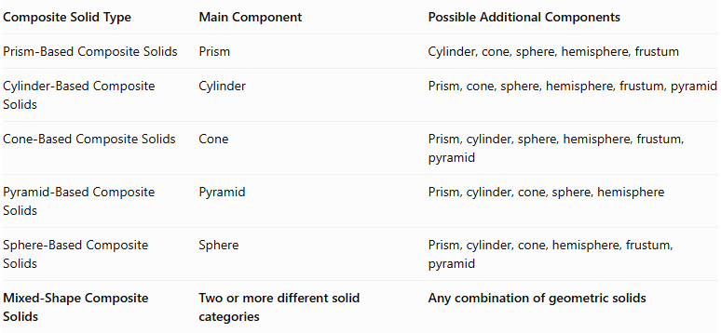
Composite Solid Type | Main Component | Possible Additional Components
Prism-Based Composite Solids | Prism | Cylinder, cone, sphere, hemisphere, frustum
Cylinder-Based Composite Solids | Cylinder | Prism, cone, sphere, hemisphere, frustum, pyramid
Cone-Based Composite Solids | Cone | Prism, cylinder, sphere, hemisphere, frustum, pyramid
Pyramid-Based Composite Solids | Pyramid | Prism, cylinder, cone, sphere, hemisphere
Sphere-Based Composite Solids | Sphere | Prism, cylinder, cone, hemisphere, frustum, pyramid
Mixed-Shape Composite Solids | Two or more different solid categories | Any combination of geometric solids
Main distinction: The first five categories are organized around a particular primary solid type, whereas mixed-shape composite solids combine different solid categories without depending on one specific primary component.

Applications
# Source: AI Source: Provided by: [Data Path: Persons Table -> ID Column: 1, Name_En Column: Motasem Essam] -> From: [ChatGPT] on [7/25/2026]
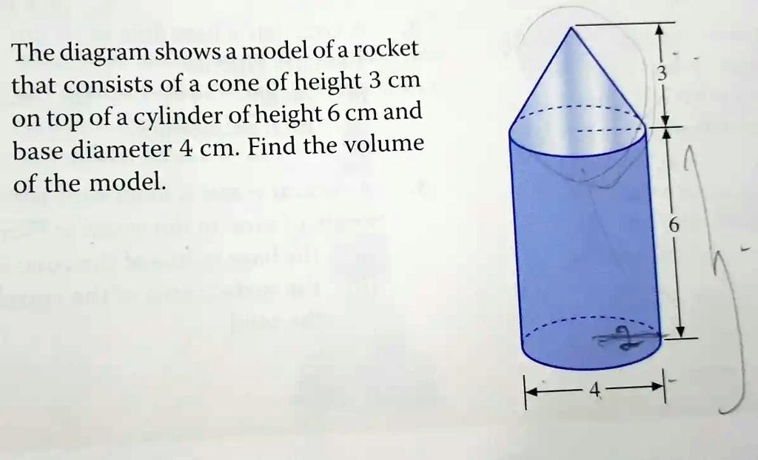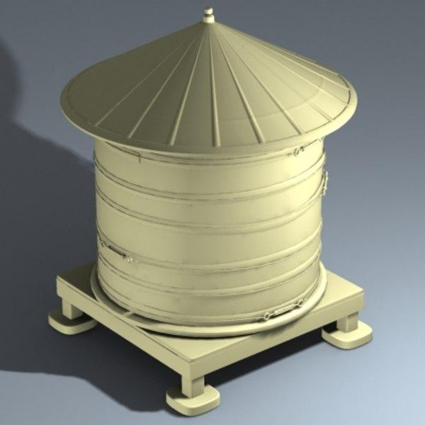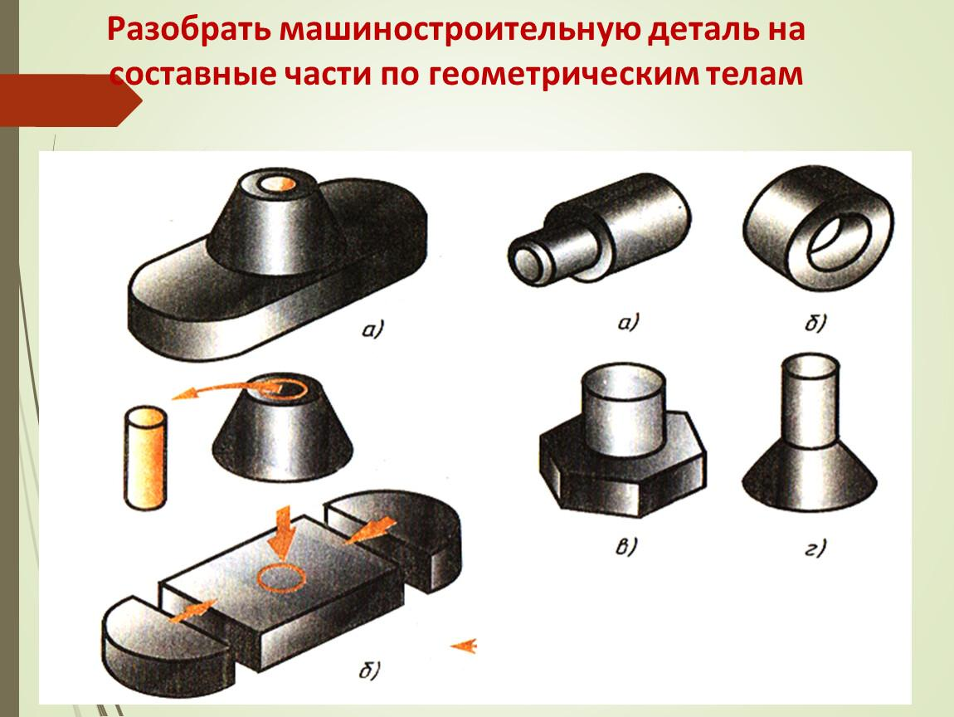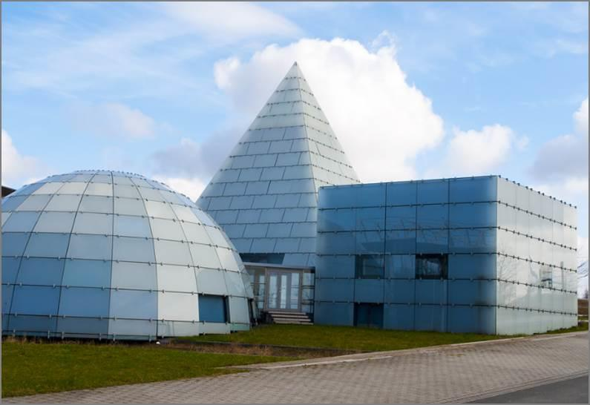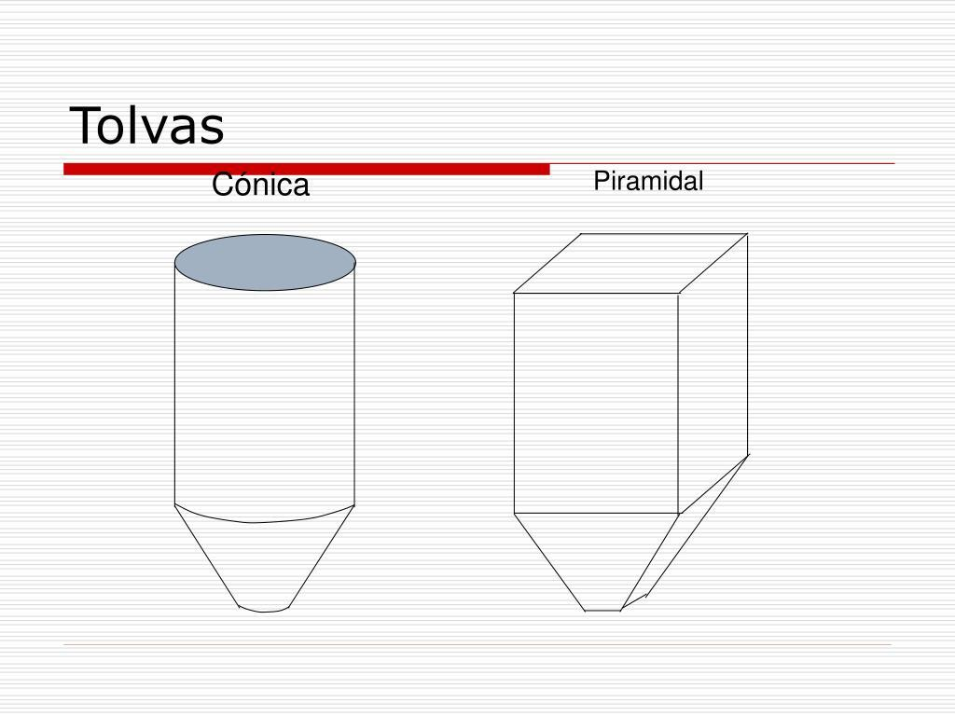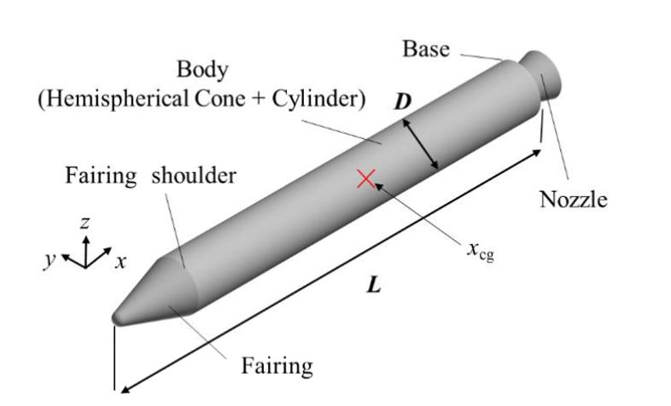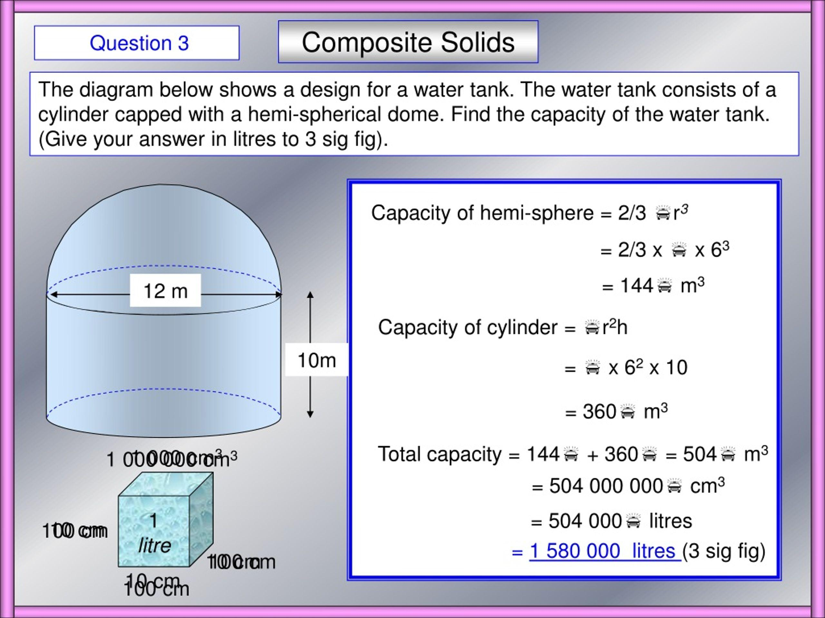
Mixed-shape composite solids are commonly found in:
- Architecture: Buildings, towers, domes, roofs, columns, and decorative structures.
- Mechanical Engineering: Machine housings, mechanical assemblies, shafts, joints, and specialized equipment.
- Manufacturing: Industrial containers, molds, tanks, machine components, and manufactured products.
- Aerospace Engineering: Rockets, spacecraft structures, fuel tanks, and aerodynamic components.
- Automotive Engineering: Engine assemblies, vehicle components, housings, and mechanical structures.
- Construction: Storage structures, support systems, water tanks, and building components.
- Product Design: Bottles, lamps, toys, containers, furniture, and household products.
- Industrial Design: Complex machinery, equipment housings, storage systems, and material-handling structures.
- Computer-Aided Design (CAD): Modeling complex three-dimensional objects by combining basic geometric solids.

Key Points
# Source: AI Source: Provided by: [Data Path: Persons Table -> ID Column: 1, Name_En Column: Motasem Essam] -> From: [ChatGPT] on [7/25/2026]
- Mixed-shape composite solids combine two or more different types of geometric solids.
- They may contain prisms, cylinders, cones, spheres, hemispheres, pyramids, and frustums.
- Their external surfaces can include both flat and curved regions.
- They can be classified by component types, number of components, arrangement, and surface combination.
- Their volume is calculated by combining component volumes while accounting for overlaps.
- Their external surface area includes only exposed surfaces.
- Joining surfaces that become internal must not be counted.
- They can contain two, three, four, or more different solid categories.
- They are useful for representing complex real-world structures and manufactured objects.

Conclusion
# Source: AI Source: Provided by: [Data Path: Persons Table -> ID Column: 1, Name_En Column: Motasem Essam] -> From: [ChatGPT] on [7/25/2026]
Mixed-Shape Composite Solids represent one of the most flexible categories of composite geometric solids because they combine two or more different types of three-dimensional shapes.
They can contain any combination of flat-faced and curved-surface solids, producing complex structures with different arrangements, dimensions, and surface characteristics.
Understanding their classification, geometric components, volume formulas, and external surface-area calculations provides a foundation for studying advanced solid geometry and its applications in engineering, architecture, manufacturing, and three-dimensional design.

